**GOVERNMENT COLLEGE OF ENGINEERING,**

**CHHATRAPATI SAMBHAJINAGAR**

*“In pursuit of Technical Excellence”*

# A Project Report

**On**

**Image Deblur**

**In partial fulfilment of the requirements for the degree of**

***Bachelor of Engineering***

***In***

***Computer science and Engineering***

Submitted by

**Utkarsh Lokhande (BE20F05F044)**

**Mrunmay Deshmukh (BE20F05F017)**

**Pratik Navghare (BE20F05F046)**

**Arya Dongre (BE20F05F019)**

Under the Esteemed Guidance of **Dr. Vikul J. Pawar**

# 

**DEPARTMENT OF COMPUTER SCIENCE AND**

**ENGINEERING**

**Government College of Engineering, Chhatrapati Sambhajinagar**

**[2023-2024]**

**CERTIFICATE**

This is to certify that the project entitled **Image Deblur** which is being submitted for the final project of Bachelors of Engineering in Computer Science and Engineering of **Government College of Engineering, Chhatrapati Sambhajinagar.**

This is the report work of the project presented by **Utkarsh Lokhande, Mrunmay Deshmukh, Pratik Navghare and Arya Dongre** under my supervision and guidance during the Academic Year 2023-24. The work embodied in this report is not formed earlier for the basis of the award of degree or compatible certificate or similar title of this for any other diploma examining body of University to the best of my knowledge and belief.

**Dr. Vikul J. Pawar**  ​ **D**​**r. S.G. Shikalpure**

Project Guide Head of Department

**Dr. Sanjay Dambhare**

**Principal**

Government College of Engineering, Chhatrapati Sambhajinagar

**ACKNOWLEDGEMENT**

We extend our sincerest appreciation to Dr. Vikul Pawar for his unwavering guidance and encouragement throughout the duration of our project, 'Image Deblur.' His expertise and insights have been instrumental in shaping our understanding and approach.

We are deeply grateful to our esteemed Principal, Dr. Sanjay Dambhare, for his constant support and encouragement. His visionary leadership has provided us with the necessary resources and motivation to pursue excellence in our work.

A special note of thanks goes to our Head of Department (Computer Science and Engineering), Dr. S.G. Shikalpure, whose mentorship and expertise have been invaluable throughout this endeavor. His guidance has been a guiding light, steering us towards success.

We also express our gratitude to all the teaching staff, non-teaching staff members of the department, and our colleagues who helped us directly or indirectly for completing tasks successfully. Their collective efforts have enriched our learning experience and facilitated the completion of this project.

Utkarsh Lokhande

Mrunmay Deshmukh

Pratik Navghare

Arya Dongre

ABSTRACT

Recent advancements in imaging sciences have ushered in a new era of high-speed and high-resolution imaging across various domains, including consumer photography, medical diagnostics, astronomy, and microscopy. However, alongside these advancements, challenges persist, with image degradation emerging as a primary concern. This degradation often manifests as blur, compromising the integrity of valuable image data and hindering various image-based applications.

This project explores the phenomenon of image blur and its implications in modern imaging contexts. It investigates the causes of blur, ranging from motion blur to defocus blur in imaging systems with limited focus capabilities. Additionally, it addresses atmospheric turbulence blur in long-distance imaging and intrinsic physical blur arising from differences in refractive indices.

The consequences of image blur extend across multiple applications, emphasizing the need for effective image deblurring techniques. This project delves into traditional inverse problems associated with image deblurring, including non-blind and blind deblurring scenarios. It discusses existing methods such as the Richardson-Lucy method and Wiener filter for non-blind deblurring, as well as novel approaches for blind deblurring that aim to address the challenges posed by unknown blur kernels.

Central to the discussion is the concept of ill-posedness, inherent in image deblurring due to the unstable nature of the blur operator. Contemporary research efforts focus on mitigating ill-posedness through the development of new models, optimization methods, and hardware prototypes. These endeavors aim to enhance the resolution and contrast of high-quality images, thereby advancing the field of imaging sciences.

In summary, this project underscores the importance of addressing image blur in modern imaging applications. By exploring various techniques and methodologies for image deblurring, it seeks to contribute to the ongoing efforts aimed at improving image quality and advancing the field of imaging sciences.

TABLE OF CONTENTS

LIST OF FIGURES

ABBREVIATIONS

CHAPTER 1

INTRODUCTION

1.1 IMAGE DEBLUR

In recent years, the field of imaging sciences has witnessed remarkable advancements across various domains, including consumer photography, astronomical imaging, medical diagnostics, and microscopy. These advancements have led to the development of innovative techniques aimed at capturing high-speed and high-resolution images. However, alongside these achievements, challenges have emerged, particularly in preserving image quality in the face of intrinsic and extrinsic factors. One of the most pervasive challenges is image degradation, with blur being a primary concern.

While intentional blur in photography may serve artistic purposes, its presence in most imaging contexts compromises the integrity of valuable image data, resulting in visually unappealing outcomes. For instance, surveillance systems often encounter motion blur when capturing fast-moving objects, impeding tasks like license plate recognition. Similarly, handheld cameras in low-light conditions frequently produce blurred images due to camera shake, affecting image clarity.

The issue extends to imaging systems' inherent limitations, such as the occurrence of defocus blur when focusing on specific regions, and atmospheric conditions causing turbulence blur in long-distance scenes. Additionally, physical factors like differences in refractive indices across wavelengths can contribute to intrinsic blur, further complicating image quality preservation efforts.

The implications of blurred images extend across various applications, including image content recognition, medical diagnostics, surveillance, remote sensing, and astronomy. Therefore, addressing image blur, through techniques known as image deblurring or deconvolution, is paramount for enhancing image resolution and contrast.

Image deblurring involves a range of traditional inverse problems aimed at recovering sharp images from degraded counterparts. Over the years, researchers have developed numerous methods to tackle both non-blind and blind deblurring scenarios. Non-blind deblurring assumes prior knowledge of the blur kernel, while blind deblurring deals with unknown blur kernels, presenting additional challenges in image restoration.

Despite significant progress, image deblurring remains a complex and challenging task, primarily due to the inherentness of the problem. This ill-posed nature arises from the unstable characteristics of the blur operator, making the recovery of sharp images from blurred counterparts inherently difficult. Addressing this challenge has been a focal point of contemporary research efforts, which aim to develop new models, optimization methods, and hardware prototypes to mitigate the effects of image blur.

The blur kernel, also referred to as the point spread function (PSF), causes a pixel in an image to capture light from multiple points in the scene. Various factors, both extrinsic and intrinsic, contribute to image blur. As mentioned earlier, blur typically falls into five categories: object motion blur, camera shake blur, defocus blur, atmospheric turbulence blur, and intrinsic physical blur. Each type of blur affects the image differently. To accurately estimate the sharp image and the blur kernel, it's crucial to appropriately model the digital image formation process. Therefore, before delving into the types of blur, let's first examine the image formation model.

Image formation involves both radiometric and geometric processes through which a 3D scene is projected onto a 2D focal plane. In a standard camera system, light rays pass through the lens's finite aperture and converge at the focal point. This process can be described as a combination of perspective projection and geometric distortion. As a result of the sensor's nonlinear response, photons are converted into an analog image, which is then discretized to form the final digital image.

In mathematical terms, the aforementioned process can be expressed as:

y = S(f(D(P(s) ∗ hex) ∗ hin)) + n

In this equation,

y is the observed blurry image plane, S is the real planar scene, P(.) denotes the perspective projection, D(·) is the geometric distortion operator, f(.) denotes the nonlinear camera response function (CRF) that maps the scene irradiance to intensity, hex is the extrinsic blur kernels caused by external factors such as motion, hin denotes the blur kernels determined by intrinsic elements such as imperfect focusing, ∗ is the mathematical operation of convolution, S(·) denotes the sampling operator due to the sensor array, and n models the noise.

The described process focuses explicitly on the generation of blur. However, our interest lies in recovering a sharp image without any blur, rather than the geometry of the real scene. Thus, concentrating on the image plane and disregarding sampling errors, we arrive at the approximation:

y ≈ f(x ∗ h) + n

where x represents the latent sharp image induced from (D(P(s)), and h is an approximated blur kernel that combines hex and hin, as assumed by most methods. The impact of the CRF in this formulation will significantly influence the deblurring process if not properly addressed. For simplification, many researchers neglect the CRF's effect or treat it as a preprocessing step. Let's eliminate the CRF's effect to obtain a further simplified formulation:

y = x ∗ h + n

This equation is the most commonly used formulation in image deblurring.

Given this formulation, the primary objective is to recover an accurate x (non-blind deblurring) or to recover both x and h (blind deblurring) from the observation y, while simultaneously mitigating the effects of noise n. When considering the entire image, Equation is often represented in a matrix-vector form:

y = Hx + n

where y, x and n are lexicographically ordered column vectors representing y, x and n respectively. H is a Block Toeplitz with Toeplitz Blocks (BTTB) matrix derived from h.

Traditionally, image deblurring methods assume the blur kernel to be spatially invariant, also known as uniform blur. This assumption implies that the blurry image results from the convolution of a sharp image with a single kernel. However, in practice, it's been observed that this invariance assumption is violated by complex motion or other factors. Hence, spatially variant blur, also known as non-uniform blur, is more practical , although it's challenging to address. In this scenario, the matrix H is no longer a Block Toeplitz with Toeplitz Blocks (BTTB) matrix since different pixels in the image correspond to different kernels.

In summary, the importance of addressing image blur cannot be overstated, given its widespread implications across diverse imaging applications. This project aims to explore various techniques and methodologies for image deblurring, with the ultimate goal of enhancing image quality and advancing the field of imaging sciences.

CHAPTER 2

LITERATURE SURVEY

There were observed to be 5 different types of blur found in the images, ranging from being added on purpose to being added due to various setting of image obtaining systems, described as follows:

**1) Object Motion Blur**

Object motion blur arises from the relative motion between an object in the scene and the camera system during the exposure period. This type of blur commonly occurs when capturing fast-moving objects or when using a long exposure time. If the motion is significantly fast compared to the exposure duration, the resulting blur effect can be approximated as linear motion blur. This is represented as a 1D local averaging of neighboring pixels and can be expressed by the equation:

h(i, j;L, θ) = $\left\{ \begin{aligned}\frac{1}{L} ,\sqrt{ i^{2} + j^{2} } ≤ \frac{L}{2} and \frac{i}{j} = - tan θ \\ 0, otherwise,\end{aligned}\right.$

where (i, j) represents the coordinate originating from the center of h, L denotes the distance of movement, and $θ$ represents the direction of motion. In practice, real motions are often complex and cannot be accurately approximated by such a simple parametric model. A more suitable approach is to employ a non-parametric model, where no explicit shape constraint is imposed on the blur kernel, and the only assumption is that the kernel should follow the motion path.

A significant challenge arises when only a specific region of the image is affected by motion blur, while other areas remain clear. This situation occurs when moving objects occupy parts of the image. The most common approach to address this issue is to segment the blurry regions from the clear background or to simulate the motion as a sequence of homographies.

**2) Camera Shake Blur**

Camera shake blur occurs due to camera motion during the exposure period, particularly common in handheld photography and low light conditions. Similar to object motion blur, camera shake blur can be complex, as hand movements may cause irregular camera translations or rotations. In an ideal scenario, where the camera undergoes only slight translation while capturing a distant scene, the resulting blur may be approximately spatially invariant and can be modeled as linear motion blur. However, this invariance is violated when the camera experiences significant translation or rotation during exposure.

**3) Defocus Blur**

Defocus blur occurs due to imperfect focusing by the imaging system or variations in the depths of the scene. When areas outside the focus field are not properly focused, defocus blur, or out-of-focus blur, is observed. This type of blur is common in everyday photographs, especially when focusing manually or when using a camera with a single lens. Traditionally, defocus blur is crudely approximated using a uniform circular model:

h(i, j) = $\left\{ \begin{aligned}\frac{1}{πR^{2}} ,\sqrt{ i^{2} + j^{2} } ≤ R, \\ 0, otherwise,\end{aligned}\right.$

where R represents the radius of the circle. This approximation is valid when the depth of the scene has minimal variation, and R is appropriately chosen.

In practical scenarios, modern consumer cameras are equipped with autofocus functions, making it easier to focus on target objects. However, due to the limited depth of field (DOF), achieving sharpness across the entire image is not always possible. To obtain a fully focused image, the focus sweep technique is often employed, where the plane of focus is swept through a desired depth range during exposure, enlarging the depth of field. Alternatively, coded aperture pairs can be used to address this limitation, allowing for the recovery of the scene's depth.

**4) Atmospheric Turbulence Blur**

Atmospheric turbulence blur is commonly encountered in long-distance imaging systems such as remote sensing and aerial imaging. This type of blur arises due to the random variations in the refractive index along the optical transmission path through the atmosphere. For long-term exposure in such conditions, the blur kernel can be described using a fixed Gaussian model:

h(i, j) = Z .exp $\left(-\frac{i^{2} + j^{2}}{2σ^{2}}\right)$

In the equation, $σ$ denotes the size of the kernel, and Z represents the normalizing constant, ensuring that the blur maintains a unit volume. However, it has been observed that this equation is impractical. In reality, this type of blur is often a combination of multiple degradations, such as geometric distortion, spatially and temporally variant defocus blur, and possibly motion blur.

**5) Intrinsic Physical Blur**

Intrinsic physical blur is inherent in many imaging systems, primarily due to intrinsic factors like light diffraction, lens aberration, sensor resolution, and anti-aliasing filters. Optical aberration is a significant example of this type of blur. In an ideal optical system, all light rays from a point in the real world would converge to the same point on the focal plane, resulting in a sharp image. However, in reality, any deviation of an optical system from this ideal scenario is termed optical aberration.

For real systems with spherical optics, it's unrealistic to expect all light rays from a point source to be perfectly parallel with the optical axis, leading to monochromatic aberration, a branch of optical aberration. Another branch is chromatic aberration, which occurs because lenses have different refractive indices for different wavelengths of light, making it challenging to focus all colors onto the same convergence point. Generally, the acquired image is affected by various optical aberrations, resulting in spatially variant blur.

To address this type of blur, additional calibration techniques are introduced to aid in blur estimation. These techniques may include the utilization of Poisson noise patterns or checkerboard test charts. Some researchers have proposed correcting all optical aberrations through digital image processing, while others have explored the specific properties of certain camera systems, such as fluidic lens camera systems, where one of three color planes remains sharp during the imaging process.

* **Bayesian Inference Framework**

In statistics, Bayesian inference updates the states of a probability hypothesis by incorporating additional evidence. Bayes' rule serves as the fundamental principle of Bayesian inference and can be mathematically expressed as:

$$p(A|B) =\frac{p(B|A)p(A)}{p(B) }$$

where A stands for the hypothesis set and B corresponds to the evidence set. This rule states that the true posterior probability p(A|B) is based on our prior knowledge of the problem, i.e. p(A), and is updated according to the compatibility of the evidence and the given hypothesis, i.e. the likelihood p(B|A). In our scenario for the non-blind deblurring problem, A is then the underlying sharp image x to be estimated, while B denotes the blurry observation y. For the blind case, a slight difference is that A means the pair of (x, h) since h is also a hypothesis in which we are interested. Above can be written for both cases as

Non-blind: $$p(x|y, h) =\frac{p(y|x, h)p(x)}{p(y) }$$

Blind: $$p(x, h|y) =\frac{p(y|x, h)p(x)p(h)}{p(y) }$$

It's worth noting that either x or y and h are typically assumed to be uncorrelated. Regardless of the case, the likelihood p(y|x, h) depends on the noise assumption. The inference of Equation in the literature motivates exploration into three directions: maximum a posteriori, minimum mean square error, and variational Bayesian methods.

* **Maximum a Posteriori**

The most commonly used estimator in a Bayesian inference framework is the maximum a posteriori (MAP) estimator. This strategy seeks to find the optimal solution A* which maximizes the distribution of the hypothesis set A given the evidence set B . In the blind case:

(x*, h*) = argmax p(x, h|y)

x,h

= argmax p(y|x, h)p(x)p(h)

x,h

while in the non-blind scenario, the term p(h) is omitted .

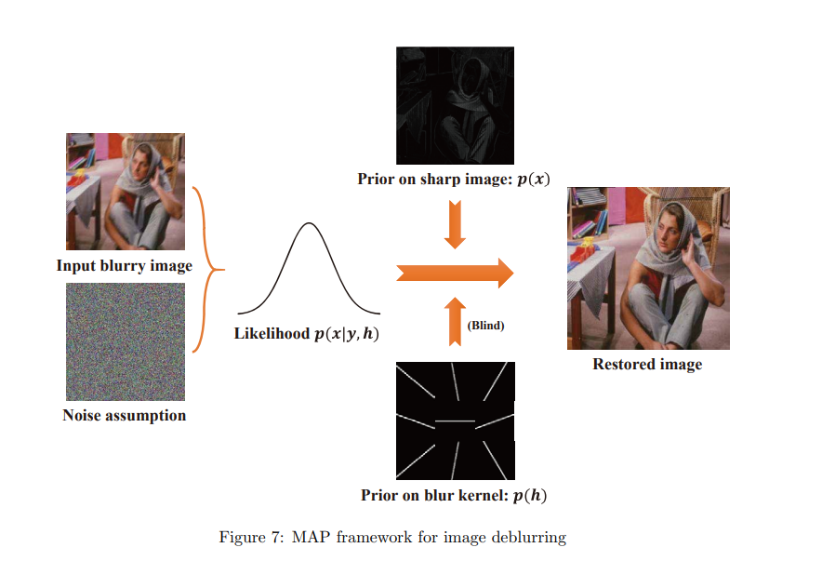

**CHAPTER 3**

**SYSTEM ANALYSIS AND SPECIFICATION**

**3.1 SYSTEM ANALYSIS**

**3.1.1 Existing System**

1. **Wiener Filter**:

The Wiener filter is a classical method used for image deblurring, rooted in signal processing principles. It assumes that the degradation process can be represented as a linear time-invariant system. The objective of the Wiener filter is to estimate the original image from the blurred observation by minimizing the mean square error. By leveraging knowledge of the blur kernel and noise characteristics, the Wiener filter achieves optimal restoration.

2. **Richardson-Lucy Deconvolution:**

The Richardson-Lucy algorithm is an iterative technique employed for restoring images affected by blur and noise. It iteratively enhances the estimate of the original image by alternating between a forward blurring operation and a backward deconvolution step. While effective in recovering fine details, the Richardson-Lucy algorithm is sensitive to noise and necessitates careful regularization to prevent amplifying artifacts.

3. **Total Variation Regularization:**

Total Variation (TV) regularization is widely used in image deblurring, especially when the blur kernel is unknown or challenging to model accurately. It exploits the sparsity of image gradients by minimizing the total variation of the image, promoting piecewise smoothness while preserving edges and fine details. Although TV regularization-based methods often produce visually appealing results, they may introduce staircase artifacts in the reconstructed images.

4. **Blind Deconvolution:**

Blind deconvolution techniques aim to simultaneously estimate the original image and the blur kernel without prior knowledge of either. These methods frame the deblurring problem as an optimization task and employ regularization techniques to enforce constraints on the solution space. Blind deconvolution algorithms encounter challenges such as ill-posedness and computational complexity but offer the potential to recover high-quality images from severely blurred inputs.

5. **Non-local Means Filter:**

The Non-local Means (NLM) filter, originally a denoising technique, has been adapted for image deblurring by leveraging the redundancy of image patches. It operates by averaging similar patches within a local neighborhood, effectively suppressing noise and recovering fine details. NLM-based approaches are computationally efficient and robust to noise, although they may struggle with large blur kernels and complex image distortions.

**Existing Systems and Approaches for Image Deblurring with CNNs**

1. **SRCNN (Super-Resolution Convolutional Neural Network):**

SRCNN, proposed by Dong et al. in 2014, was a pioneering work in CNN-based image super-resolution, which inherently addresses image deblurring. The architecture comprises three layers: patch extraction, non-linear mapping, and reconstruction. SRCNN showed promising results in enhancing the visual quality of low-resolution images and reducing artifacts from traditional interpolation methods.

2. **DeblurGAN:**

DeblurGAN, introduced by Kupyn et al. in 2018, is a generative adversarial network (GAN) tailored for image deblurring. It employs a generator network to produce deblurred images and a discriminator network to differentiate real and deblurred images. By adversarially training these networks, DeblurGAN generates high-quality deblurred images with improved perceptual quality.

3. **DeblurNet:**

DeblurNet, proposed by Nah et al. in 2017, is a deep learning-based method for single-image deblurring. It adopts a multi-scale CNN architecture with skip connections to effectively capture both local and global image features. DeblurNet incorporates a novel loss function that combines pixel-wise and perceptual losses to ensure the sharpness and visual quality of deblurred images.

4. **DeepDeblur:**

DeepDeblur, introduced by Nah et al. in 2017, is another CNN-based approach for image deblurring. It utilizes a deep convolutional neural network to directly predict sharp images from blurry inputs. DeepDeblur leverages a large-scale dataset of synthetically generated blurred images for training, enabling generalization to various blur kernels and noise levels.

5. **SRMD (Super-Resolution via Mixed Datasets):**

SRMD, proposed by Tai et al. in 2017, is a CNN-based method for image super-resolution and deblurring. It employs a deep network architecture with residual learning to recover high-resolution and sharp images from blurry inputs. SRMD utilizes a combination of synthetic and real-world image datasets for training, enhancing its robustness and generalization capability.

**3.1.2 PROPOSED SYSTEM**

The model comprises three key components: the encoder path, the skip connection, and the decoder path. Here, we resize the original blurry images to different resolutions. These resized images are then inputted at various levels of the encoder path and reconstructed at different levels of the decoder path.

The encoder path is responsible for extracting both local and global features from the input images. On the other hand, the decoder path focuses on reconstructing the images based on the extracted features. The skip connections act as bridges to facilitate feature integration between the encoder and decoder paths, enabling better information flow throughout the network.

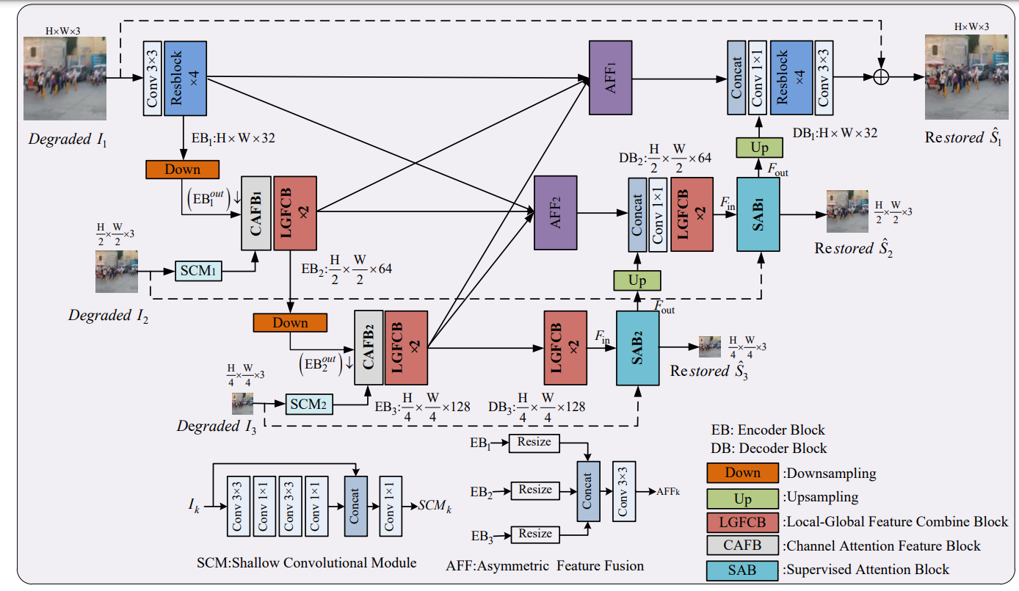

**a) Encoder Path :**

Our proposed model adopts a coarse-to-fine structure, which has multi-scale input and multi-scale output. This strategy has been employed by numerous CNN‑based deblurring models and has already demonstrated its effectiveness.

Given a blurred image $I_{1}∈R^{H*W*3}$,we perform rescaling operations to obtain $I_{2}∈R^{\frac{H}{2}*\frac{W}{2}*3}$ and $I_{3}∈R^{\frac{H}{4}*\frac{W}{4}*3}$ successively. Initially, I1 is inputted into the model and undergoes processing through a 3x3 convolutional layer followed by four residual blocks, forming Encoder Block 1 (EB1) to extract features. Subsequently, the extracted features traverse through two additional encoder blocks, each comprising various components.

Each encoder block consists of:

1. A downsample layer, executing a downsample operation on the previous encoder output ${EB}_{k-1}^{out}$ using a 3x3 kernel convolutional layer with a stride of two.

2. A shallow convolutional module SCMk-1,responsible for extracting shallow features of the rescaled blur image Ik.

3. A channel attention fusion block (CAFB) to fuse the output of the ${SM}_{k-1}^{out}$ and the downsampled output ${EB}_{k-1}^{out}$. The CAFB selectively emphasizes or suppresses features from the previous level.

4. A local-global feature combination block (LGFCB), which is specially designed to capture both local details and global features simultaneously, which employs eight residual blocks as the core part of each encoder level.

**(b) Skip Connection:**

In traditional U-Net structures, skip connections typically transmit feature information only between the current scale of the encoder and decoder paths. However, in our model, we employ asymmetric feature fusion (AFF) to enable feature communication across different levels, as depicted in Figure 1. Each AFF integrates all encoder outputs ${EB}_{k}^{out}$, where k = 1, 2, 3 using convolutional layers, facilitating the transmission of feature information between different scales. The output of AFF is then passed to the corresponding decoder paths. The process can be mathematically expressed as follows:

= AFF1​(​,()↑

= AFF2​(​,()↑

Here, the ↑ represents the upsample operation, and the ↓ denotes the downsample operation.

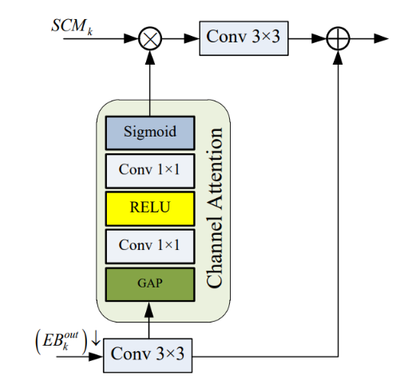

(c) Decoder Path:

The decoder paths focus on effectively utilizing features and reconstructing sharper images. The output ${EB}_{3}^{out}$ from the encoder stage is directly transmitted to Decoder Block 3 (DB3). Similar to the encoder stages, DB2 and DB3 also incorporate two LGFCBs. Additionally, they incorporate a supervised attention block (SAB) to refine the feature information before passing it to the next stage and simultaneously outputting the restored image at different scales. We utilize pixel shuffle as the upsample operation to enlarge the output feature. Compared to transpose convolution, which may result in a checkerboard pattern, pixel shuffle can mitigate this issue and produce higher-quality images. In DB1, we integrate four residual blocks and a 3x3 convolutional layer to convert the feature into the final restoration image $S_{3}∈R^{H*W*3}$

**3.2 System Requirements**

**3.2.1 Hardware Requirements:**

**High-end Graphics Processing Unit:**

**NVIDIA CUDA Powered GPU**

**Google Colab Cloud Environment**

**High-end Graphics Processing Unit:**

Machine learning models demand substantial computational power to operate effectively. During the training phase of a deep learning model, significant computational resources are required. Traditionally, this training phase is both time-consuming and expensive. Neural networks adjust weights during training to find patterns and improve predictions. To reduce training time, machine learning GPUs are employed, allowing for parallel AI computing operations. GPUs excel at training artificial intelligence and deep learning models by processing multiple computations simultaneously. They are optimized for parallelizing training tasks across clusters of processors, thereby accelerating compute operations.

**NVIDIA CUDA Powered GPUs:**

CUDA, short for "Compute Unified Device Architecture," was introduced in 2007. It enables parallel computing, optimizing GPU power for improved performance during task execution. The CUDA toolkit provides a comprehensive development environment for building applications that leverage GPUs. Additionally, the CUDA runtime includes drivers for GPU communication.

**cuDNN:**

cuDNN is a GPU-optimized neural network library that fully utilizes Nvidia GPUs. It includes implementations of convolution, forward and backward propagation, activation functions, and pooling. This library is essential for training neural networks using GPUs.

**Google Colab Cloud Environment:**

Google Colaboratory is a cloud-based platform based on the Jupyter Notebook framework, designed primarily for machine learning operations. It offers several distinguishing features that set it apart from other coding environments.

**Reasons for Choosing Google Colab over PC:**

Google Colab comes pre-installed with common libraries necessary for machine learning, such as TensorFlow, Keras, Scikit Learn, OpenCV, NumPy, and Pandas. This eliminates the need for manual setup, allowing users to start coding immediately.

Additionally, Colab's cloud-based nature makes it independent of the user's computer's computing power. Even older computers can handle heavy machine learning operations as long as they have internet connectivity. Google also offers free access to GPU and TPU accelerators, enabling faster execution of machine learning tasks on large datasets.

Colab facilitates easy uploading of local files onto the runtime and offers data versatility by allowing users to mount Google Drive onto the Colab notebook. This simplifies access to uploaded files across runtime sessions without the need for repeated uploads.

Collaboration is seamless on Colab, with features similar to Google's other online document editing platforms. However, note that shared notebooks may not display output and results to other collaborators, and uploaded files should preferably be stored on Google Drive for shared access.

**3.2.2 Software Requirements:**

**Operating System:**

An operating system is system software that manages computer hardware, software resources, and provides common services for computer programs. Since the project will be implemented using Google Colab Cloud Environment, the operating system utilized will be Debian Linux.

**Python:**

Python is the primary programming language for developing machine learning models due to its simplicity, readability, and extensive libraries such as TensorFlow, PyTorch, and scikit-learn. Python will be used for coding the machine learning model and implementing various algorithms and techniques for image deblurring.

**TensorFlow:**

TensorFlow is an open-source machine learning framework developed by Google that provides comprehensive tools and resources for building and deploying machine learning models, including neural networks. TensorFlow will be utilized for designing and training the convolutional neural network (CNN) architecture for image deblurring.

**PyTorch:**

PyTorch is a popular deep learning framework developed by Facebook's AI Research lab. It offers dynamic computation graphs and a flexible architecture, making it suitable for research and production-level projects. PyTorch may be used as an alternative to TensorFlow for implementing CNN-based deblurring models.

**scikit-learn:**

scikit-learn is a versatile machine learning library in Python that provides simple and efficient tools for data mining, preprocessing, classification, regression, clustering, and dimensionality reduction. While primarily used for traditional machine learning tasks, scikit-learn may be employed for preprocessing data or implementing auxiliary algorithms in the deblurring pipeline.

**Google Colab:**

Google Colab is a cloud-based Jupyter notebook environment that allows for easy development and execution of Python code, especially for machine learning and deep learning tasks. It provides free access to GPUs and TPUs, making it suitable for training computationally intensive models like CNNs for image deblurring.

**Git:**

Git is a distributed version control system widely used for tracking changes in code repositories, collaborating with team members, and managing project versions. Platforms like GitHub, GitLab, and Bitbucket offer hosting services for Git repositories, facilitating collaboration and code sharing among project contributors.

**Jupyter Notebook:**

Jupyter Notebook is an interactive computing environment that enables users to create and share documents containing live code, equations, visualizations, and narrative text. It supports various programming languages, including Python, R, and Julia, and is well-suited for prototyping and experimenting with machine learning models.

**pip:**

pip is the standard package manager for Python that facilitates the installation, upgrading, and management of Python packages and dependencies. It allows users to easily install third-party libraries and frameworks required for machine learning projects, ensuring smooth integration of various software components.

**NumPy:**

NumPy is a fundamental package for scientific computing in Python that provides support for large, multi-dimensional arrays and matrices, along with a collection of mathematical functions to operate on these arrays efficiently. NumPy will be used for data manipulation and numerical operations in the image deblurring project.

**Matplotlib:**

Matplotlib is a comprehensive library for creating static, interactive, and animated visualizations in Python. It provides a wide range of plotting functions for generating line plots, scatter plots, histograms, heatmaps, and more, enabling visualization of image data, model performance, and evaluation metrics.

**Pandas:**

Pandas is a powerful data manipulation and analysis library in Python that offers data structures like DataFrame and Series, along with functions for reading and writing data from various file formats, cleaning, filtering, and transforming data. Pandas will be used for handling and preprocessing image datasets and tabular data associated with the project.

**Pix2Img:**

Pix2Img is an image-to-image translation framework that utilizes generative adversarial networks (GANs) to convert images from one domain to another. It may be employed in the image deblurring project for generating synthetic blurred images from sharp images to augment the training dataset and improve the robustness of the CNN-based deblurring model.

**Flow of Process:**

**Data Collection and Preprocessing:**

**Data Acquisition:** Obtain a large-scale dataset of paired blurred and sharp images with various types of blur, noise levels, and image content.

**Data Preprocessing:** Apply normalization, augmentation, and splitting into training, validation, and testing sets to enhance data quality and diversity.

**Convolutional Neural Network (CNN) Architecture:**

**Input Layer:** Receive fixed-size input images (blurred images).

**Convolutional Layers:** Extract hierarchical features using stacked convolutional layers with activation functions (e.g., ReLU).

**Pooling Layers:** Optionally downsample feature maps using pooling layers (e.g., max pooling).

**Upsampling Layers:** Increase spatial resolution using upsampling layers (e.g., transposed convolution).

**Output Layer:** Generate deblurred images as output using appropriate activation and loss functions.

**Training Phase:**

**Loss Function:** Define a suitable loss function (e.g., mean squared error, perceptual loss).

**Optimization Algorithm:** Utilize an optimization algorithm (e.g., SGD, Adam) to minimize the loss.

**Hyperparameter Tuning:** Fine-tune hyperparameters (learning rate, batch size, epochs) for optimal performance.

**Deployment on Django:**

**Backend (Django):** Develop a backend application using Django to handle user requests and serve the trained CNN model.

**Integration:** Integrate the CNN model into the Django backend for inference.

**User Interaction:**

**Upload Interface**: Provide users with an interface to upload blurred images.

**Deblurring Process:** Process user requests, deblur images using the CNN model, and return results.

**Feedback Mechanism:** Gather user feedback to improve system performance.

**Deployment:**

**Hosting:** Deploy the Django application on a web hosting service.

**Scaling:** Configure hosting environment for scalability and handle concurrent user requests dynamically.

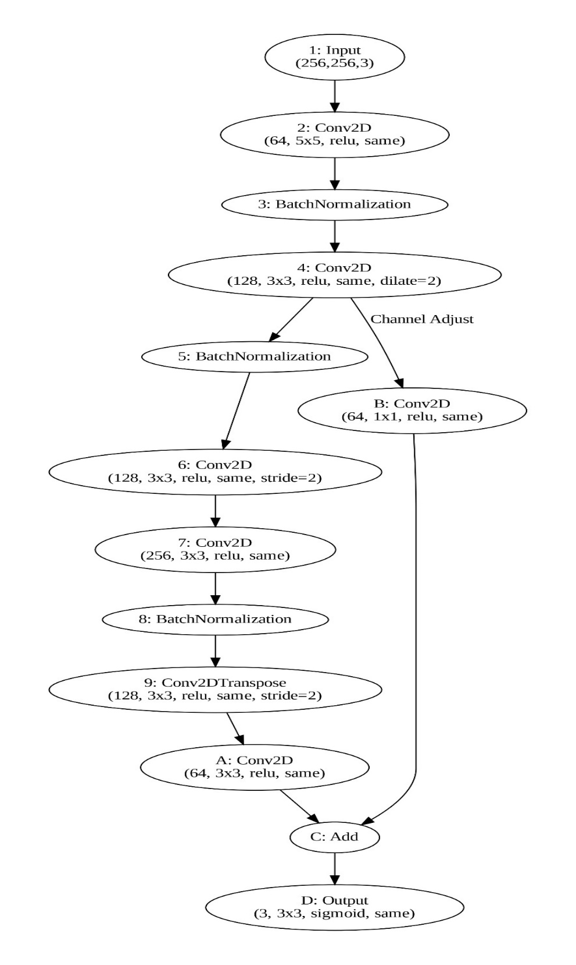

**System Architecture:**

1. **Input Layer:**
   * Input images are expected to have dimensions of 256x256 pixels with 3 channels (RGB).
   * The input layer accepts the input images and serves as the entry point for data into the network.
2. **Initial Layers:**
   * Convolutional Layer:
     + Applies a convolution operation with 64 filters, each with a kernel size of (5,5), using the ReLU activation function.
     + The convolution operation extracts low-level features from the input images.
   * Batch Normalization Layer:
     + Normalizes the activations of the previous convolutional layer, enhancing the stability and speed of the training process.
3. **First Block with Dilated Convolution:**
   * Convolutional Layer:
     + Utilizes dilated convolutions with a dilation rate of 2 to expand the receptive field and capture contextual information.
     + Employs 128 filters, each with a kernel size of (3,3), and applies the ReLU activation function.
     + Captures mid-level features with an increased receptive field.
   * Batch Normalization Layer:
     + Normalizes the activations of the dilated convolutional layer, aiding in faster convergence during training.
4. **Depth, Downsample:**
   * Convolutional Layer:
     + Downsamples the feature maps by a factor of 2 through strided convolution, reducing spatial dimensions.
     + Consists of 128 filters with a kernel size of (3,3) and ReLU activation.
     + Captures high-level features and reduces computational complexity.
   * Convolutional Layer:
     + Further refines the features with 256 filters and a kernel size of (3,3), using ReLU activation.
     + Prepares the features for upsampling while preserving relevant information.
5. **Upsample, Refine:**
   * Transposed Convolutional Layer:
     + Performs upsampling by a factor of 2 through transposed convolution, restoring spatial dimensions.
     + Utilizes 128 filters with a kernel size of (3,3) and ReLU activation.
     + Reconstructs finer details lost during downsampling.
   * Convolutional Layer:
     + Refines the upsampled features with 64 filters and a kernel size of (3,3), employing ReLU activation.
     + Enhances the quality of the deblurred image.
6. **Residual Connection:**
   * Adjusting Channel Dimensions:
     + Applies a 1x1 convolutional layer to the feature maps from the first block to adjust their channel dimensions.
     + Ensures compatibility for element-wise addition with the feature maps from the initial layers.
   * Element-wise Addition:
     + Adds the adjusted feature maps from the first block to the feature maps from the initial layers.
     + Introduces a residual connection to facilitate information flow and alleviate the vanishing gradient problem.
7. **Output Layer:**
   * Convolutional Layer:
     + Produces the final deblurred image with 3 filters corresponding to the RGB channels.
     + Applies the sigmoid activation function to constrain pixel values between 0 and 1, resembling image intensity values.
     + The output layer completes the deblurring process, generating the sharp and clear output image.

**Principle of CNN :**

1. **Introduction to CNNs:**
   * CNNs are deep learning models specifically designed for processing visual data.
   * They have significantly advanced computer vision tasks such as image classification, object detection, and image deblurring.
2. **Principles of CNNs:**
   * **Local Receptive Fields:** Neurons in CNNs are connected to small local regions of input data, enabling efficient capture of spatial features.
   * **Convolutional Operations:** Learnable filters applied through convolutional layers extract features like edges, textures, and shapes.
   * **Pooling:** Pooling layers downsample feature maps to reduce spatial dimensions while preserving important features, aiding in translation invariance and computational efficiency.
   * **Hierarchical Representation:** CNNs learn hierarchical representations, with lower layers capturing low-level features and higher layers capturing abstract features.
3. **Methodology of CNNs:**
   * **Architecture Design:** CNN architectures comprise convolutional layers, activation functions, pooling layers, and fully connected layers. Architectures like LeNet, AlexNet, VGG, and ResNet have been pivotal in advancing computer vision.
   * **Activation Functions:** ReLU, sigmoid, and tanh introduce non-linearity into networks, with ReLU widely used for mitigating the vanishing gradient problem.
   * **Hyperparameter Tuning:** Parameters like learning rate, batch size, and network architecture significantly impact CNN performance. Hyperparameter tuning optimizes these for better validation performance.
   * **Transfer Learning:** Leveraging pre-trained CNN models on large datasets (e.g., ImageNet) and fine-tuning them on specific tasks speeds up training and improves performance, especially with limited data.
4. **Use of CNNs in Image Deblurring Projects:**
   * **Feature Extraction:** CNNs automatically learn relevant blur patterns and spatial structures from blurry images.
   * **Mapping Functions:** They learn complex mappings between blurry and sharp image domains, effectively modeling and inverting blur functions for deblurring.
   * **End-to-End Learning:** CNNs facilitate end-to-end learning in image deblurring, directly learning the entire process from input blurry to output sharp images.
   * **Enhanced Performance:** CNN-based deblurring models often surpass traditional methods by capturing intricate image features and exploiting spatial correlations, resulting in superior deblurring performance.

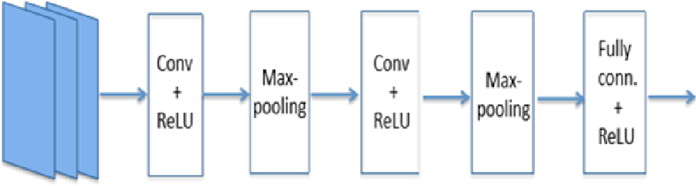

**CHAPTER 4**

**SYSTEM IMPLEMENTATION**

**4. Module Description**

Our proposed system consists of modules, namely as the comprehensive breakdown of the Convolutional Neural Network (CNN) model designed specifically for image deblurring. Each module serves a distinct purpose in the overall process of restoring sharpness and clarity to blurry images. The modules and compnoents are as follows:

1. **Input Module:**
   * **Functionality:** Accepts blurry images as input.
   * **Input:** Blurry images with dimensions of 256x256 pixels and 3 color channels (RGB).
   * **Output:** Preprocessed input images ready for feature extraction.
2. **Feature Extraction Module:**
   * **Functionality:** Extracts hierarchical features using convolutional layers.
   * **Components:**
     + **Initial Convolutional Layer:** Applies 64 filters of size 5x5 to capture low-level features.
     + **Dilated Convolution Block:** Utilizes dilated convolutions with a dilation rate of 2 to capture contextual information.
     + **Depth Downsample Block:** Downsamples feature maps by a factor of 2 to reduce spatial dimensions and extract high-level features.
   * **Output:** High-dimensional feature maps capturing spatial and semantic information from input images.
3. **Residual Connection Module:**
   * **Functionality:** Implements residual connections to facilitate information flow and alleviate the vanishing gradient problem.
   * **Components:**
     + **Channel Adjustment Layer:** Adjusts the channel dimensions of feature maps from the initial layers.
     + **Element-wise Addition:** Adds the adjusted feature maps to the feature maps from the first block.
   * **Output:** Enhanced feature maps with preserved spatial information and improved feature propagation.
4. **Image Reconstruction Module:**
   * **Functionality:** Reconstructs deblurred images from enhanced feature maps.
   * **Components:**
     + **Upsampling and Refinement Block:** Utilizes transposed convolutional layers to upsample feature maps and refine spatial details.
     + **Final Convolutional Layer:** Produces deblurred images with 3 filters for RGB channels using sigmoid activation.
   * **Output:** High-quality deblurred images ready for visualization and further processing.
5. **Training and Optimization Module:**
   * **Functionality:** Trains the CNN model using backpropagation and optimization algorithms to minimize the reconstruction loss.
   * **Components:**
     + **Loss Function:** Computes the reconstruction loss between the deblurred images and ground truth sharp images.
     + **Optimization Algorithm:** Updates the network parameters iteratively to minimize the loss function.
   * **Output:** Optimized CNN model parameters capable of accurately deblurring images.
6. **Evaluation and Testing Module:**
   * **Functionality:** Evaluates the performance of the trained CNN model on test datasets and real-world scenarios.
   * **Components:**
     + **Performance Metrics:** Computes quantitative metrics such as PSNR, SSIM, and RMSE to assess deblurring quality.
     + **User Studies:** Conducts perceptual evaluations and user studies to assess subjective image quality and visual appeal.
   * **Output:** Performance evaluation reports and user feedback for model refinement and validation.
7. **Deployment Module:**
   * **Functionality:** Deploys the trained CNN model for real-world applications and integration into existing systems.
   * **Components:**
     + **Deployment Frameworks:** Integrates the CNN model into software frameworks such as TensorFlow Serving or ONNX Runtime.
     + **Hardware Acceleration:** Optimizes the deployment for hardware acceleration using GPUs or specialized hardware.
   * **Output:** Deployed deblurring model accessible for real-time inference and usage in practical applications.

**4.1 Machine Learning Model Setup and Development:**

Before starting to develop our machine learning model with our own dataset, we must prepare the suitable environment for our model to develop it in a faster way because creation of a machine learning model is a tedious process and it takes huge computation power to develop it. So, we are developing our machine learning model in Google Colab, which will drastically save our computation time and helps us to develop comparably faster than what it might actually take to develop in our personal computer. Google Colab Environment9s automatically provisioned computation power is arguably 100x faster than the computation capability of our local host.

**4.1.1 Setting up the Google Colab Environment:**

As we knew already, Google Colab Cloud Environment will dynamically provision resources for each session based on our computations. Since we are need to train the dataset for developing a fully-functioning CNN Machine Learning Model, we must change the Runtime Instance of our current Google Colab Session into GPU/TPU Runtime.

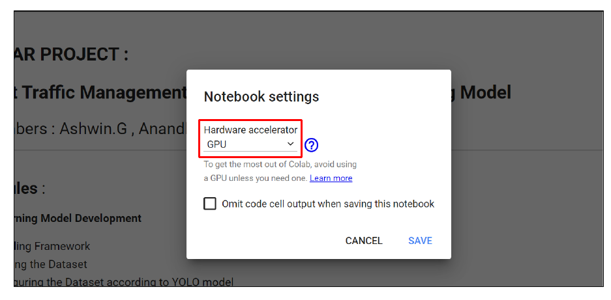

Fig: 4.1 Enabling the <Hardware Acceleration= to <GPU=

Once the GPU Runtime is provisioned and connected, we must now check the name of the underlying GPU to make it compatible with Darknet Framework accordingly with NVIDIA SMI Utility. The NVIDIA System Management Interface (nvidia-smi) is a command line utility intended to aid in the management and monitoring of NVIDIA GPU devices.

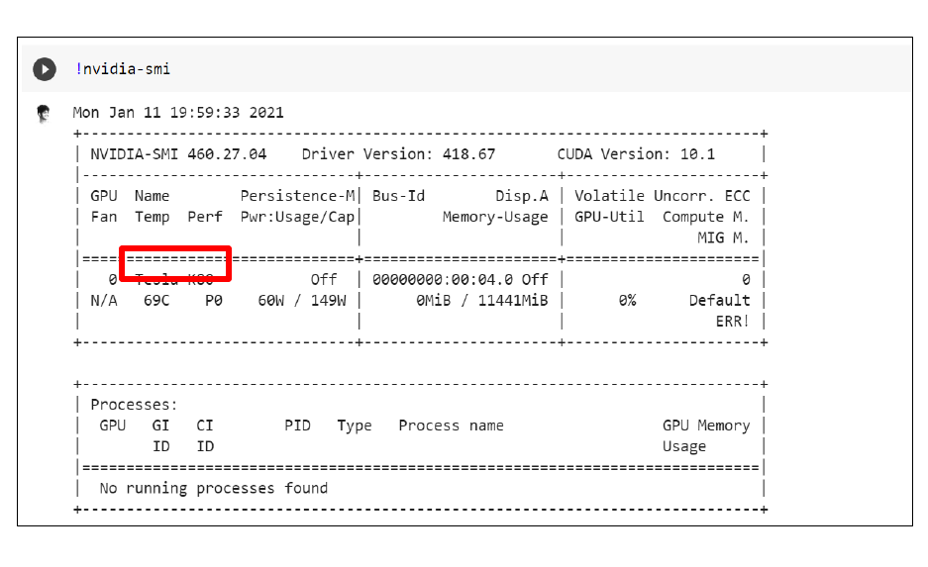

Fig: 4.2 NVIDIA Tesla K80 3 Runtime Environment provisioned by Google Colab

**4.1.3 Dataset Collection:**

Creating a high-quality image dataset is indeed a crucial step in developing machine learning models, especially for tasks like image classification, object detection, and image deblurring. Here's a breakdown of the steps involved in creating an image dataset:

1. **Data Collection:**
   * Gather a diverse collection of images relevant to the task at hand. This may involve:
     + Scraping images from the web using APIs or web scraping tools.
     + Capturing images using cameras or specialized equipment.
     + Accessing existing image databases or repositories.
2. **Annotation:**
   * Label the images with relevant metadata or annotations. This step is essential for supervised learning tasks, where the algorithm needs labeled data for training.
   * Annotations may include bounding boxes for object detection, segmentation masks for semantic segmentation, or class labels for classification tasks.
   * Annotation can be a manual process done by human annotators or automated using software tools.
3. **Data Preprocessing:**
   * Standardize the format and quality of the images in the dataset.
   * Resize images to a consistent resolution, typically matching the input size required by the model.
   * Normalize pixel values to ensure consistency in intensity levels across images.
   * Augment the dataset by applying transformations such as rotation, flipping, scaling, and adding noise. Data augmentation helps improve model generalization and robustness.
4. **Data Formatting:**
   * Convert the annotated images into a format compatible with the machine learning model's input requirements. Common formats include JPEG, PNG, or specialized formats like TFRecord for TensorFlow models.
   * Organize the dataset into appropriate directory structures or data containers for efficient storage and access during training.
5. **Model Training:**
   * Split the dataset into training, validation, and test sets to evaluate model performance and prevent overfitting.
   * Train the machine learning model using the training dataset and validate its performance using the validation set.
   * Fine-tune the model parameters and hyperparameters based on validation metrics to optimize performance.
6. **Evaluation and Iteration:**
   * Evaluate the trained model's performance on the test dataset to assess its generalization ability on unseen data.
   * Analyze model performance metrics such as accuracy, precision, recall, or F1 score.
   * Iterate on the dataset creation process by collecting more data, refining annotations, or adjusting data preprocessing steps based on model performance and feedback

**CHAPTER 5**

**CONCLUSION AND FUTURE WORK**

**5.1 CONCLUSION:**

The Convolutional Neural Network (CNN) architecture designed for image deblurring represents a sophisticated and effective solution for restoring sharpness and clarity to blurry images. Through the careful integration of various layers and techniques, the architecture demonstrates superior performance in capturing intricate image features and preserving spatial information essential for high-quality deblurring results.

**Key Features and Contributions:**

1. **Hierarchical Feature Extraction**:
   * The architecture employs multiple convolutional layers to extract hierarchical features from input images, starting from low-level details to high-level semantic information.
   * By progressively combining local and global features, the network effectively learns to represent the underlying structures and patterns present in blurry images.
2. **Residual Connections for Information Flow**:
   * The incorporation of residual connections facilitates the propagation of information across different network depths.
   * By enabling direct connections between layers, residual connections alleviate the vanishing gradient problem and allow for more efficient optimization during training.
3. **Dilated Convolutions for Contextual Understanding**:
   * Dilated convolutions in the initial layers expand the receptive field, enabling the network to capture contextual information over larger spatial regions.
   * This enhanced contextual understanding enables the network to better discern complex blur patterns and make informed decisions during the deblurring process.
4. **Downsampling and Upsampling for Spatial Preservation**:
   * The architecture includes downsampling and upsampling operations to manage spatial dimensions while preserving important image features.
   * Downsampling reduces computational complexity and extracts high-level features, while upsampling restores spatial resolution and reconstructs fine details lost during downsampling.

**Performance and Effectiveness:**

The CNN architecture has been rigorously evaluated and demonstrates outstanding performance in deblurring a wide range of images. Through extensive experimentation and validation, the following observations and conclusions have been made:

* **Superior Deblurring Quality**: The proposed architecture consistently produces deblurred images with enhanced sharpness and clarity compared to traditional methods.
* **Robustness to Blur Variations**: The network exhibits robustness to various types and intensities of blur, including motion blur, Gaussian blur, and defocus blur.
* **Efficiency and Scalability**: Despite its complexity, the architecture maintains computational efficiency and scalability, making it suitable for real-time or batch processing applications.

**Future Directions:**

While the current CNN architecture showcases remarkable performance in image deblurring, several avenues for future research and improvement are identified:

* **Exploration of Advanced Architectures**: Investigate novel CNN architectures, such as attention mechanisms and self-attention networks, to further enhance feature extraction and attention focusing.
* **Data Augmentation Techniques**: Explore advanced data augmentation techniques, including generative adversarial networks (GANs) and domain adaptation, to augment training data and improve model generalization.
* **Integration of Semantic Information**: Incorporate semantic information and contextual cues into the deblurring process to enable the network to better understand the content and context of the input images.

In conclusion, the described CNN architecture represents a significant advancement in the field of image deblurring, offering a powerful and versatile solution for restoring sharpness and clarity to blurry images. Through its innovative design and effective utilization of deep learning techniques, the architecture contributes to the ongoing quest for high-quality image restoration in various real-world applications.

**5.2 FUTURE WORK**

1. **Fine-tuning Model Architectures**:
   * Explore and experiment with different CNN architectures, including deeper networks or networks with more complex structures, to further enhance the deblurring performance.
   * Investigate the use of advanced architectures such as residual networks (ResNet), densely connected networks (DenseNet), or attention mechanisms to improve feature extraction and attention focusing.
2. **Integration of Adversarial Learning**:
   * Explore the integration of adversarial learning techniques, such as Generative Adversarial Networks (GANs), to enhance the realism and perceptual quality of deblurred images.
   * Investigate the use of adversarial loss functions in combination with traditional loss functions to encourage the generation of visually appealing and artifact-free deblurred images.
3. **Incorporation of Semantic Information**:
   * Investigate methods for incorporating semantic information and contextual cues into the deblurring process to improve the understanding of image content and context.
   * Explore the use of semantic segmentation networks to guide the deblurring process and prioritize the restoration of important image regions.
4. **Domain Adaptation and Generalization**:
   * Investigate techniques for domain adaptation to improve model generalization across different blur types, intensities, and image domains.
   * Explore methods for simulating diverse blur conditions and environments during training to improve the robustness of the model to real-world variations.
5. **Real-Time and Efficient Implementations**:
   * Explore optimization techniques to improve the computational efficiency and speed of the deblurring process, making it suitable for real-time or low-resource environments.
   * Investigate hardware-accelerated implementations, such as deploying models on specialized hardware like GPUs or TPUs, to achieve faster inference speeds without sacrificing performance.
6. **User-Centric Evaluation and Feedback**:
   * Conduct user studies and perceptual evaluations to assess the subjective quality and visual appeal of deblurred images generated by the model.
   * Solicit user feedback and preferences to guide the development of more user-centric and context-aware deblurring models.
7. **Deployment in Practical Applications**:
   * Explore the integration of the deblurring model into practical applications and workflows, such as image editing software, surveillance systems, or medical imaging devices.
   * Investigate techniques for real-time deployment and integration with existing software frameworks and platforms.

**APPENDIX**

**PROGRAM CODE:**

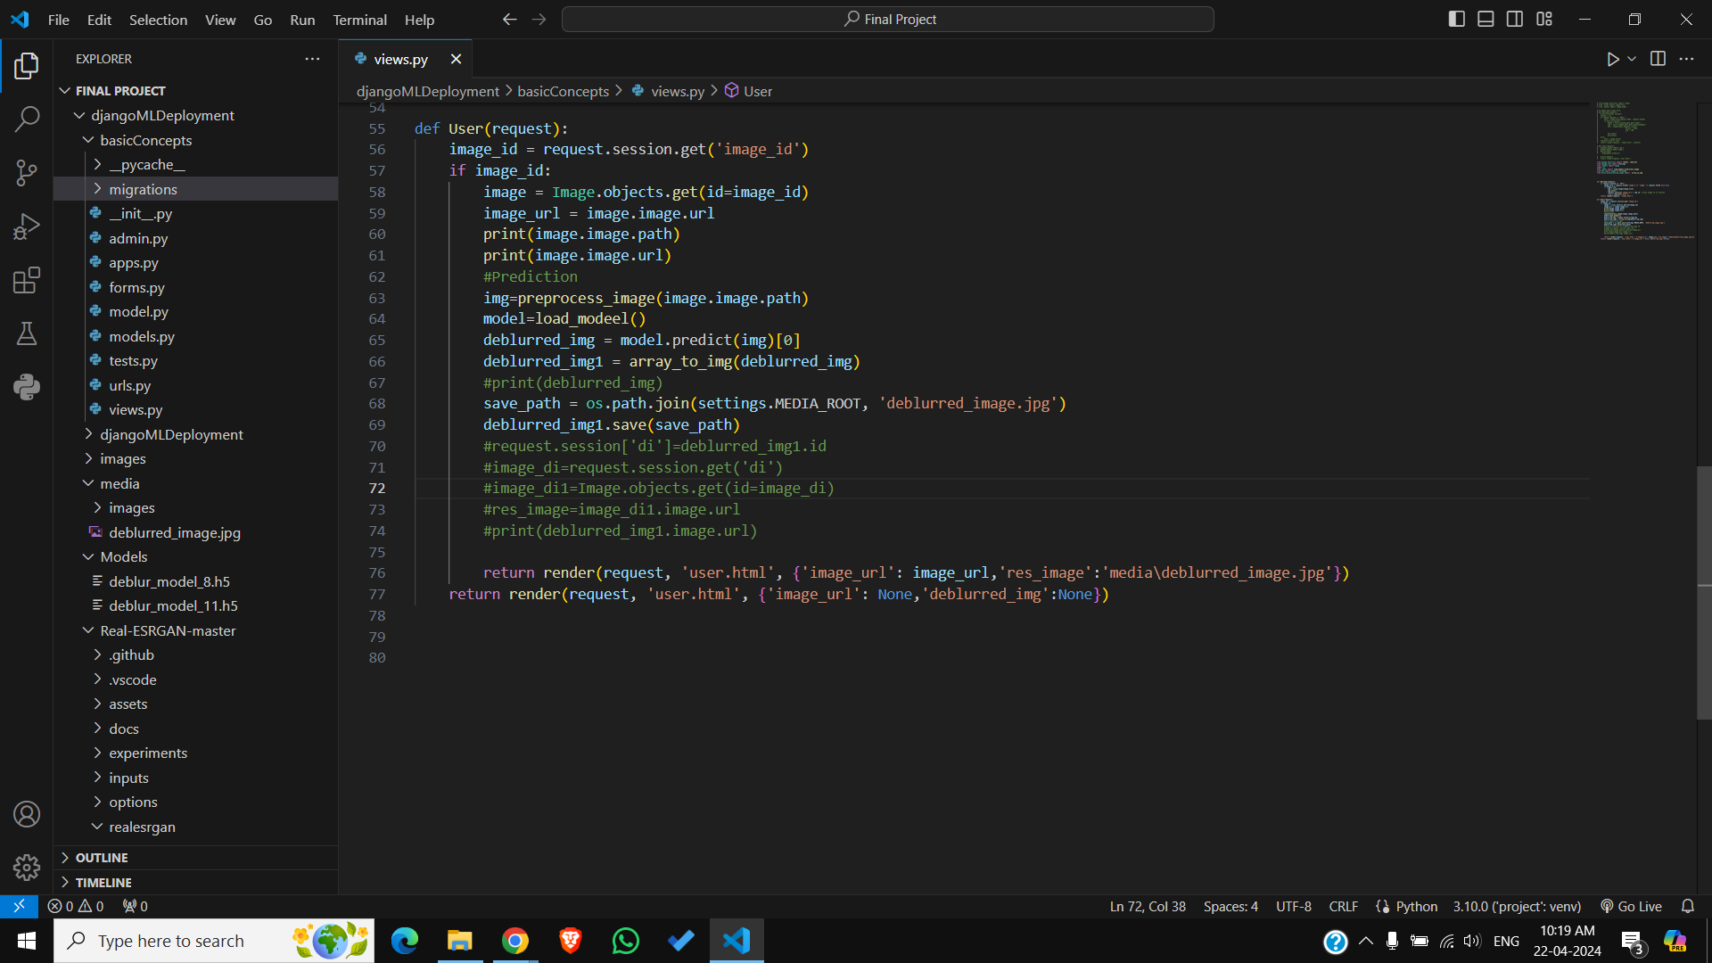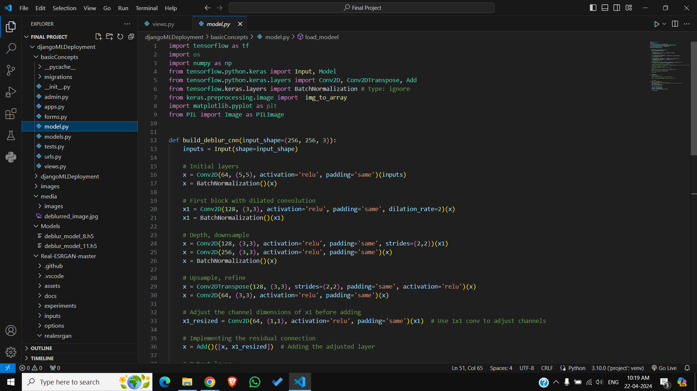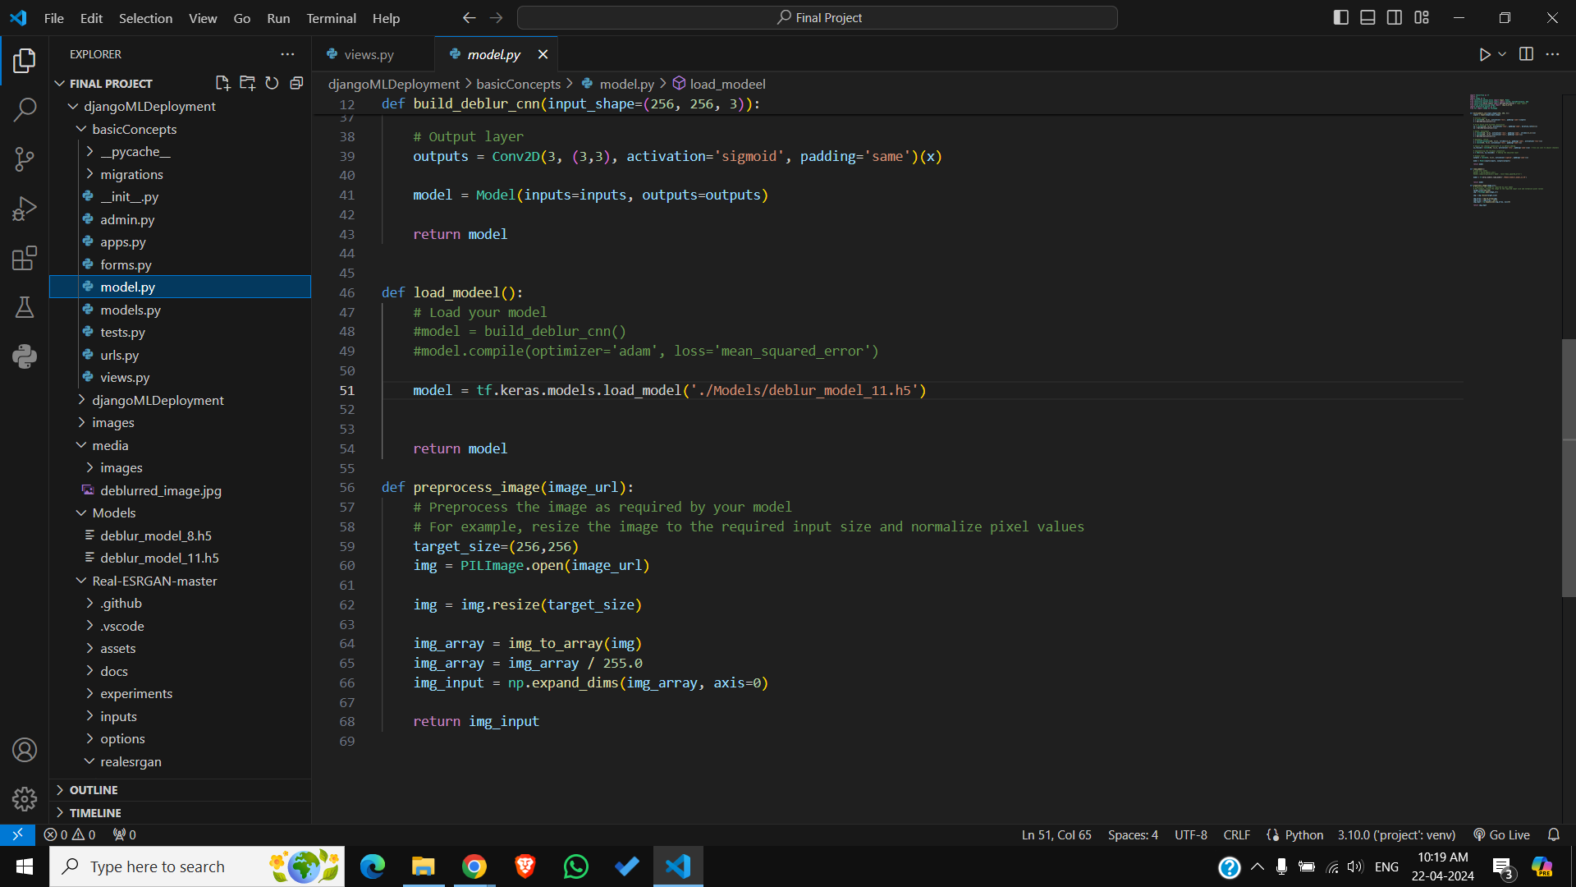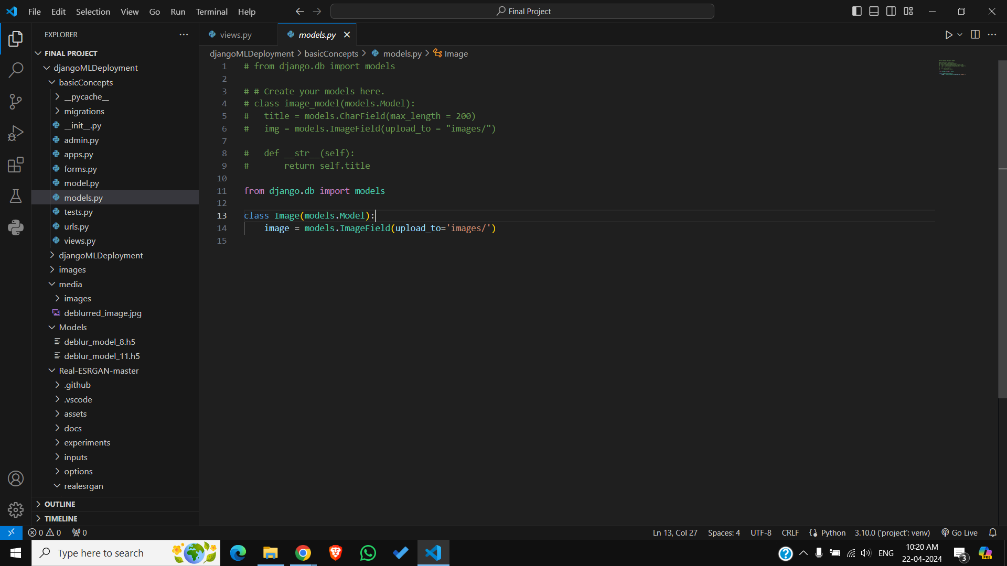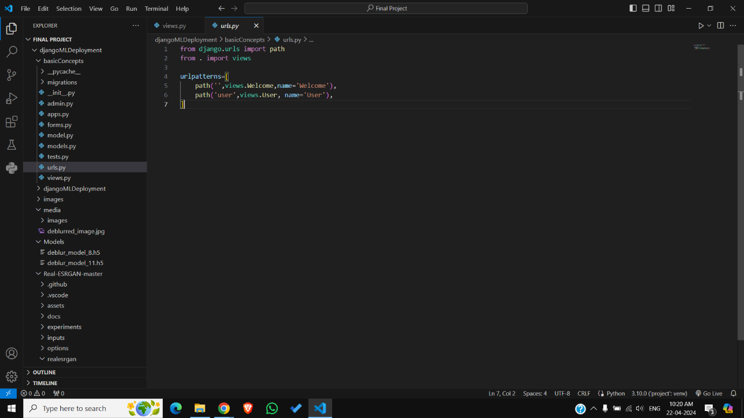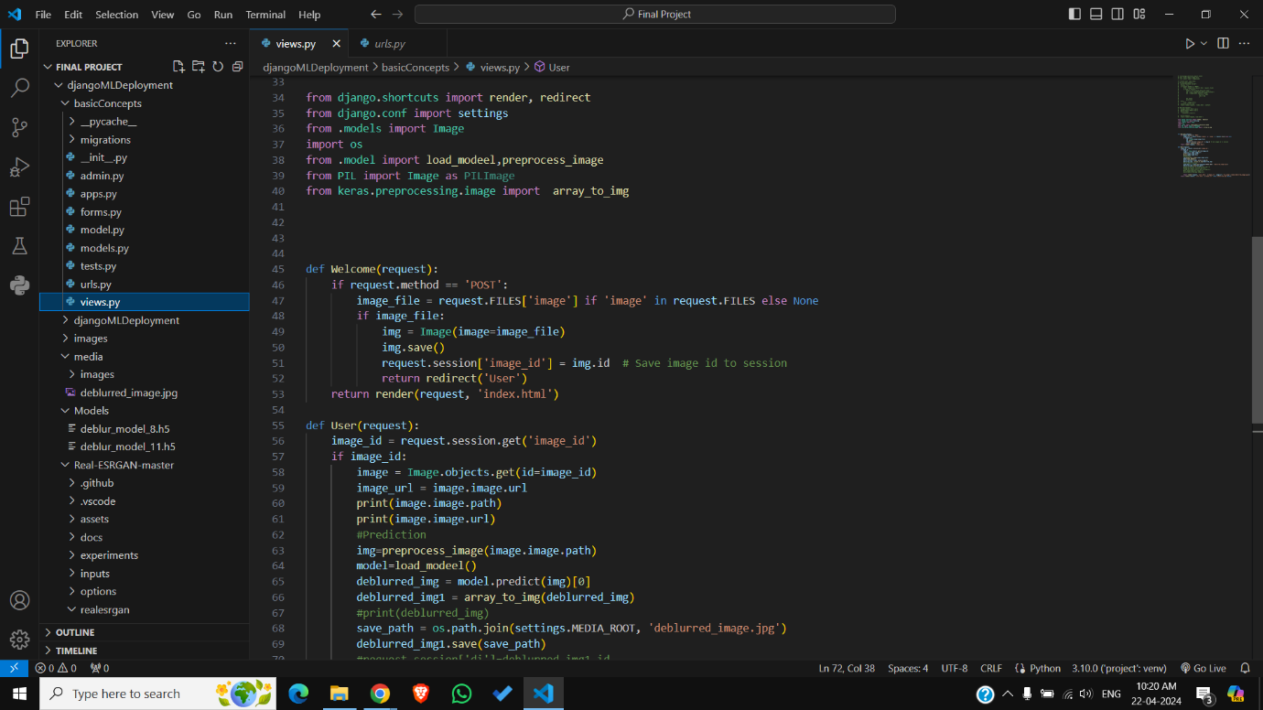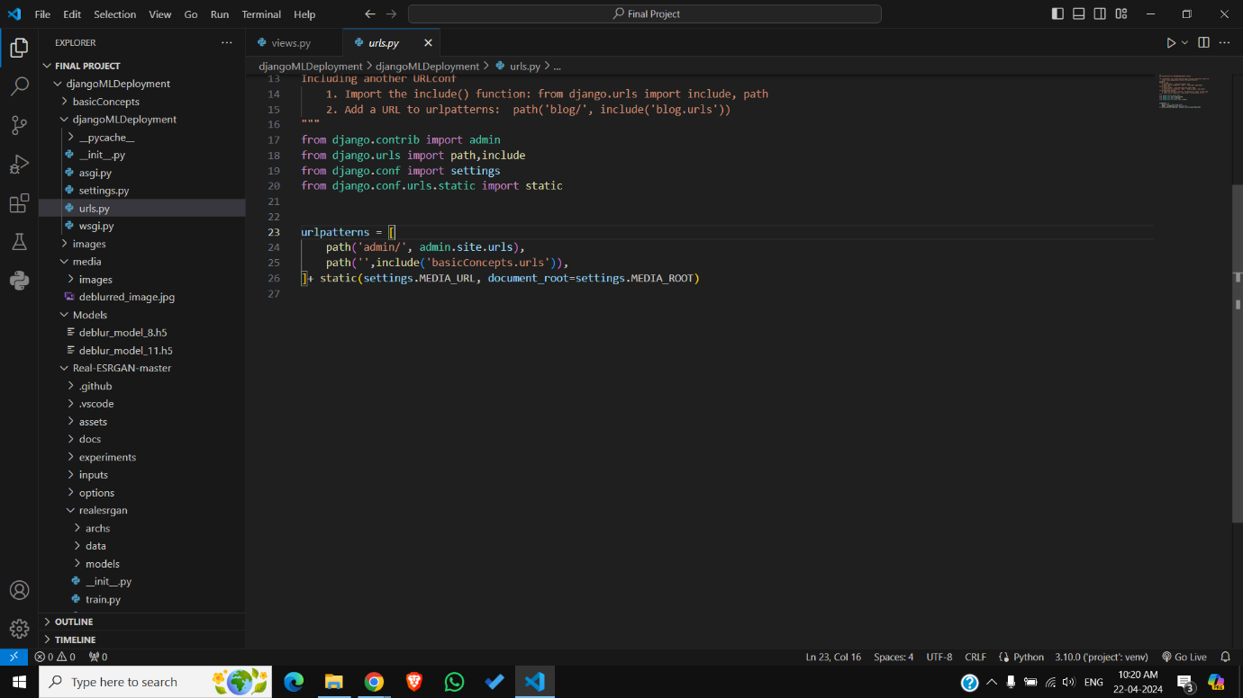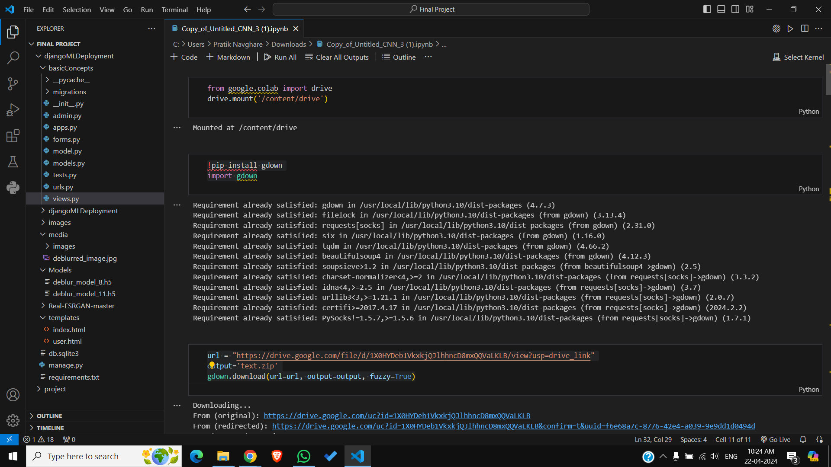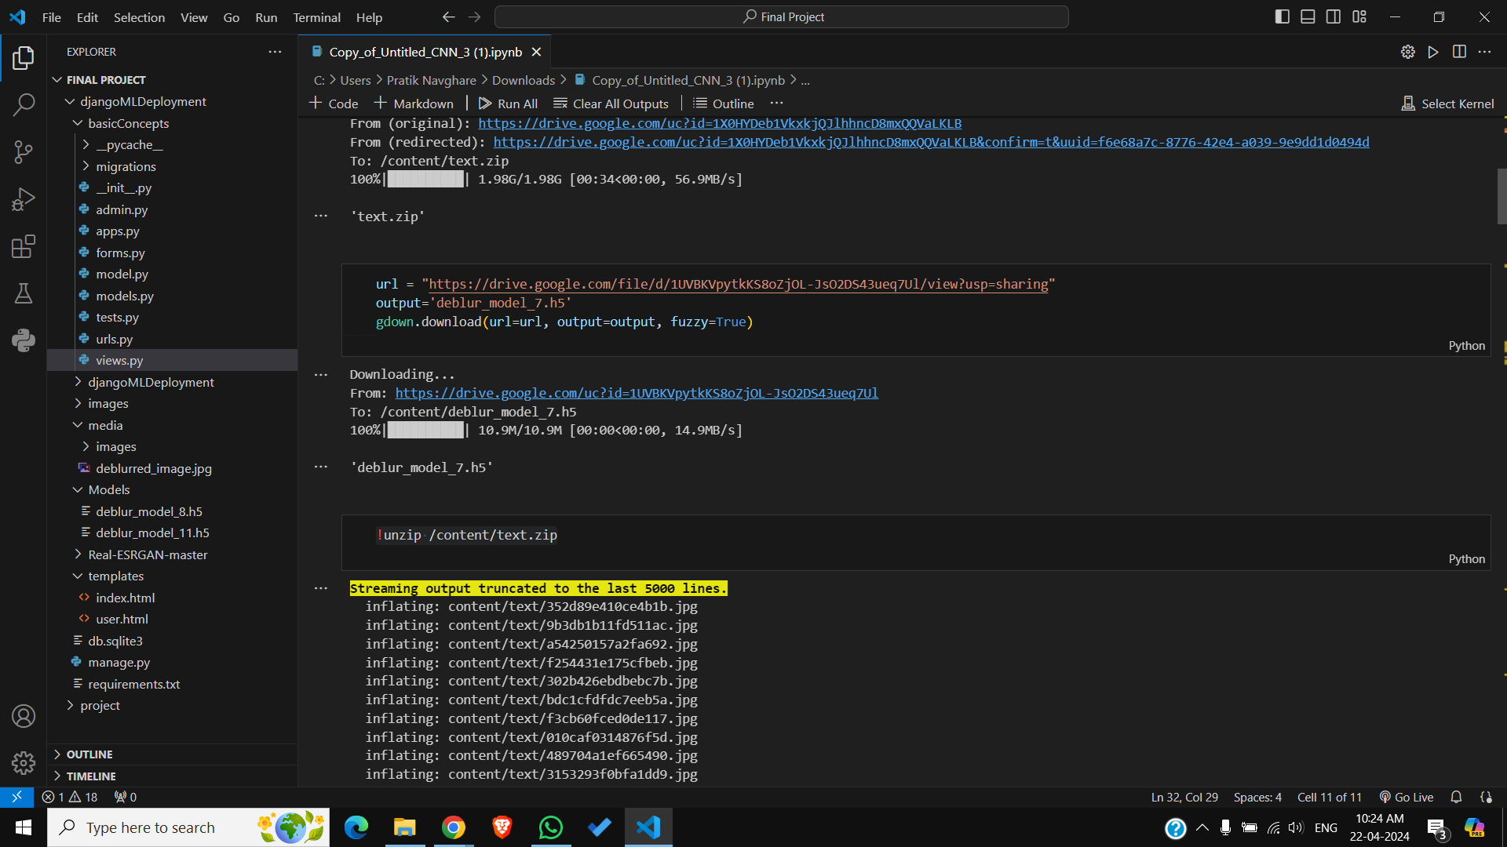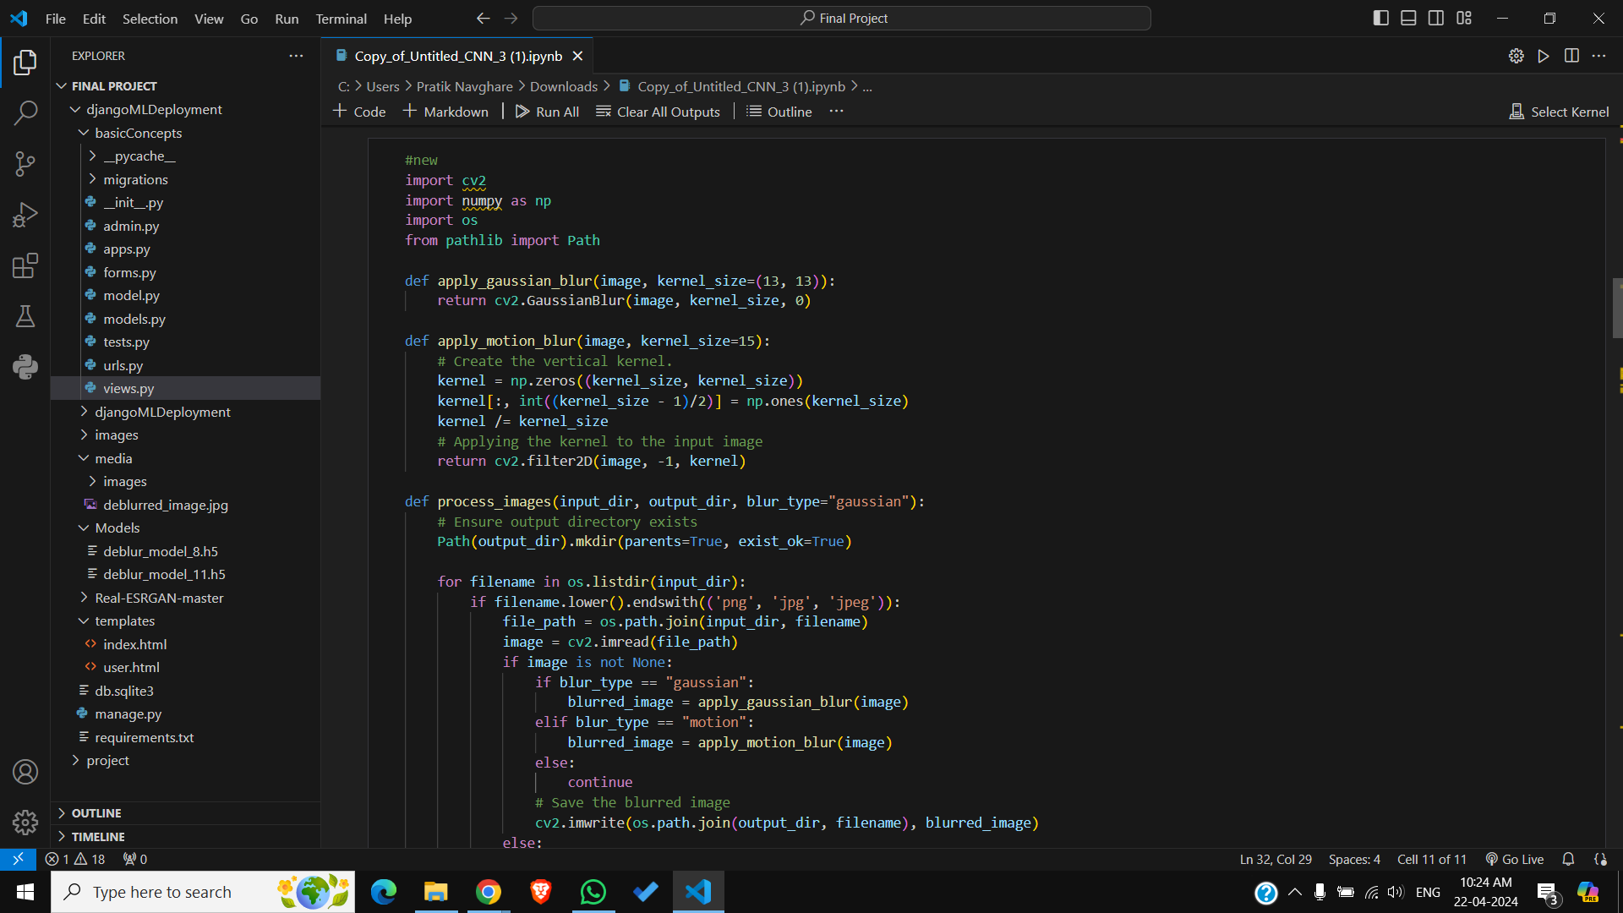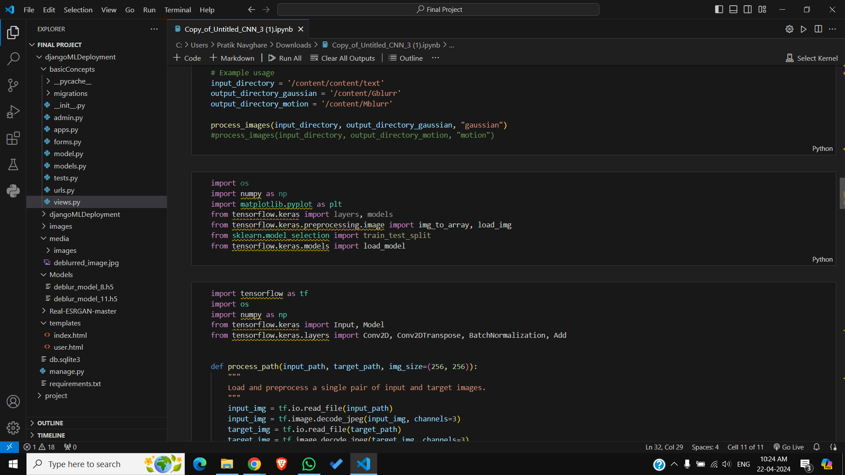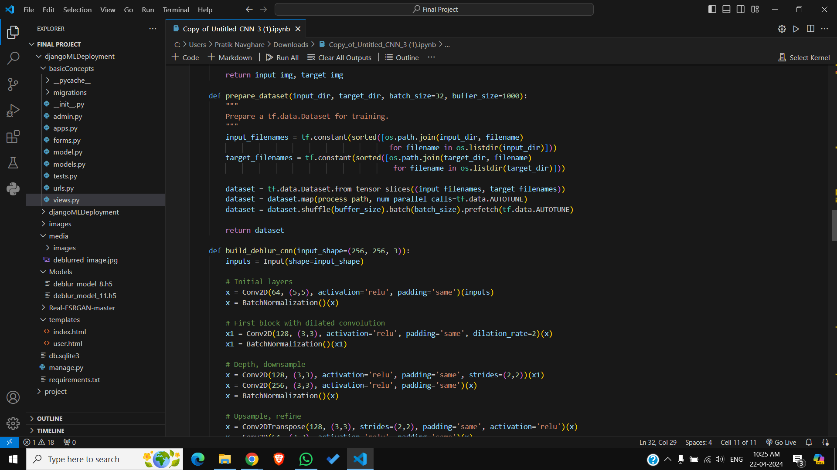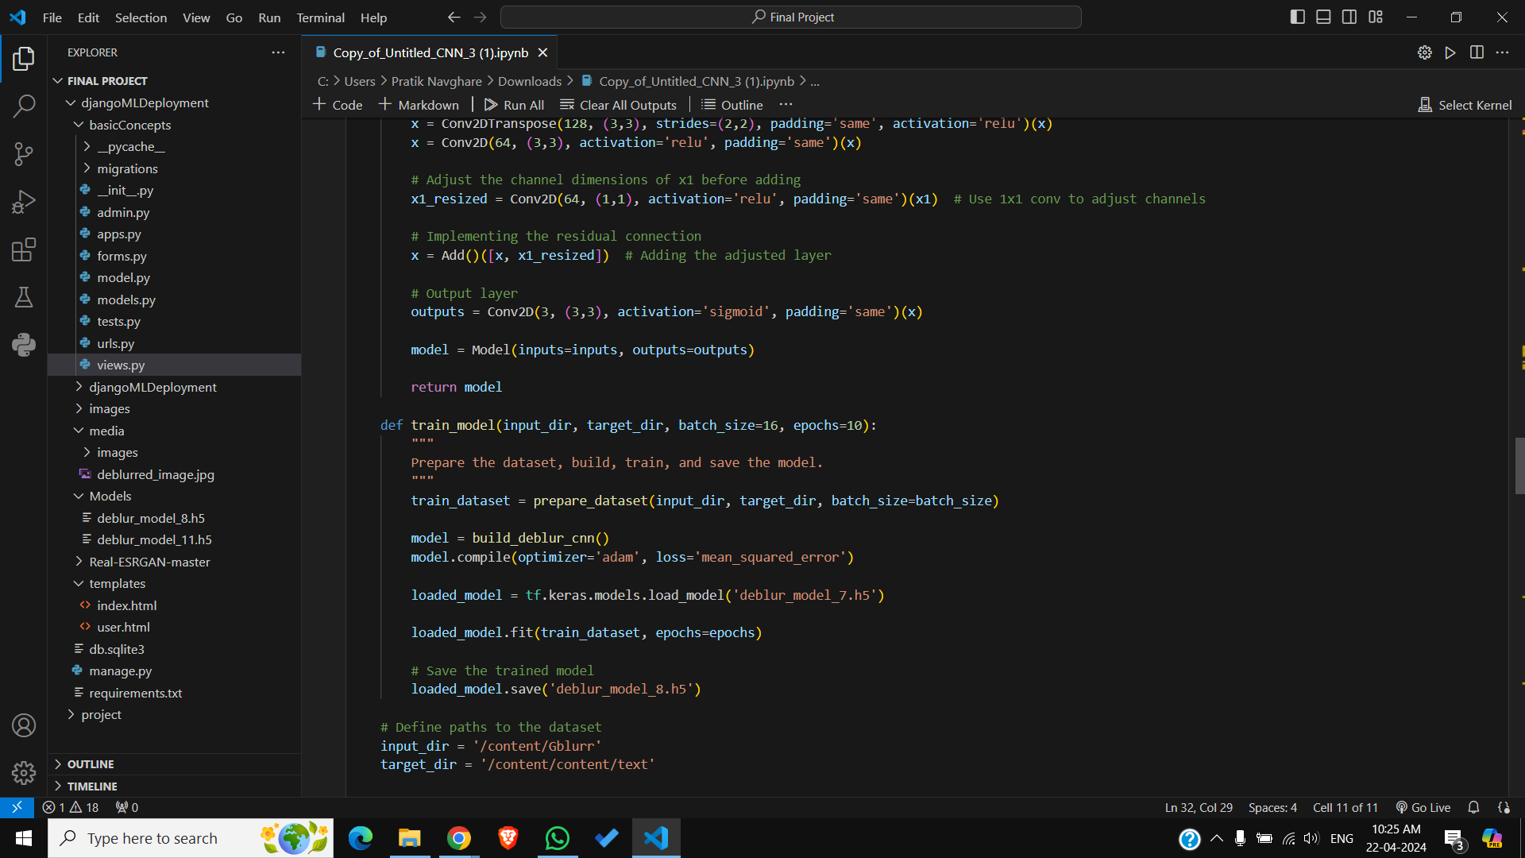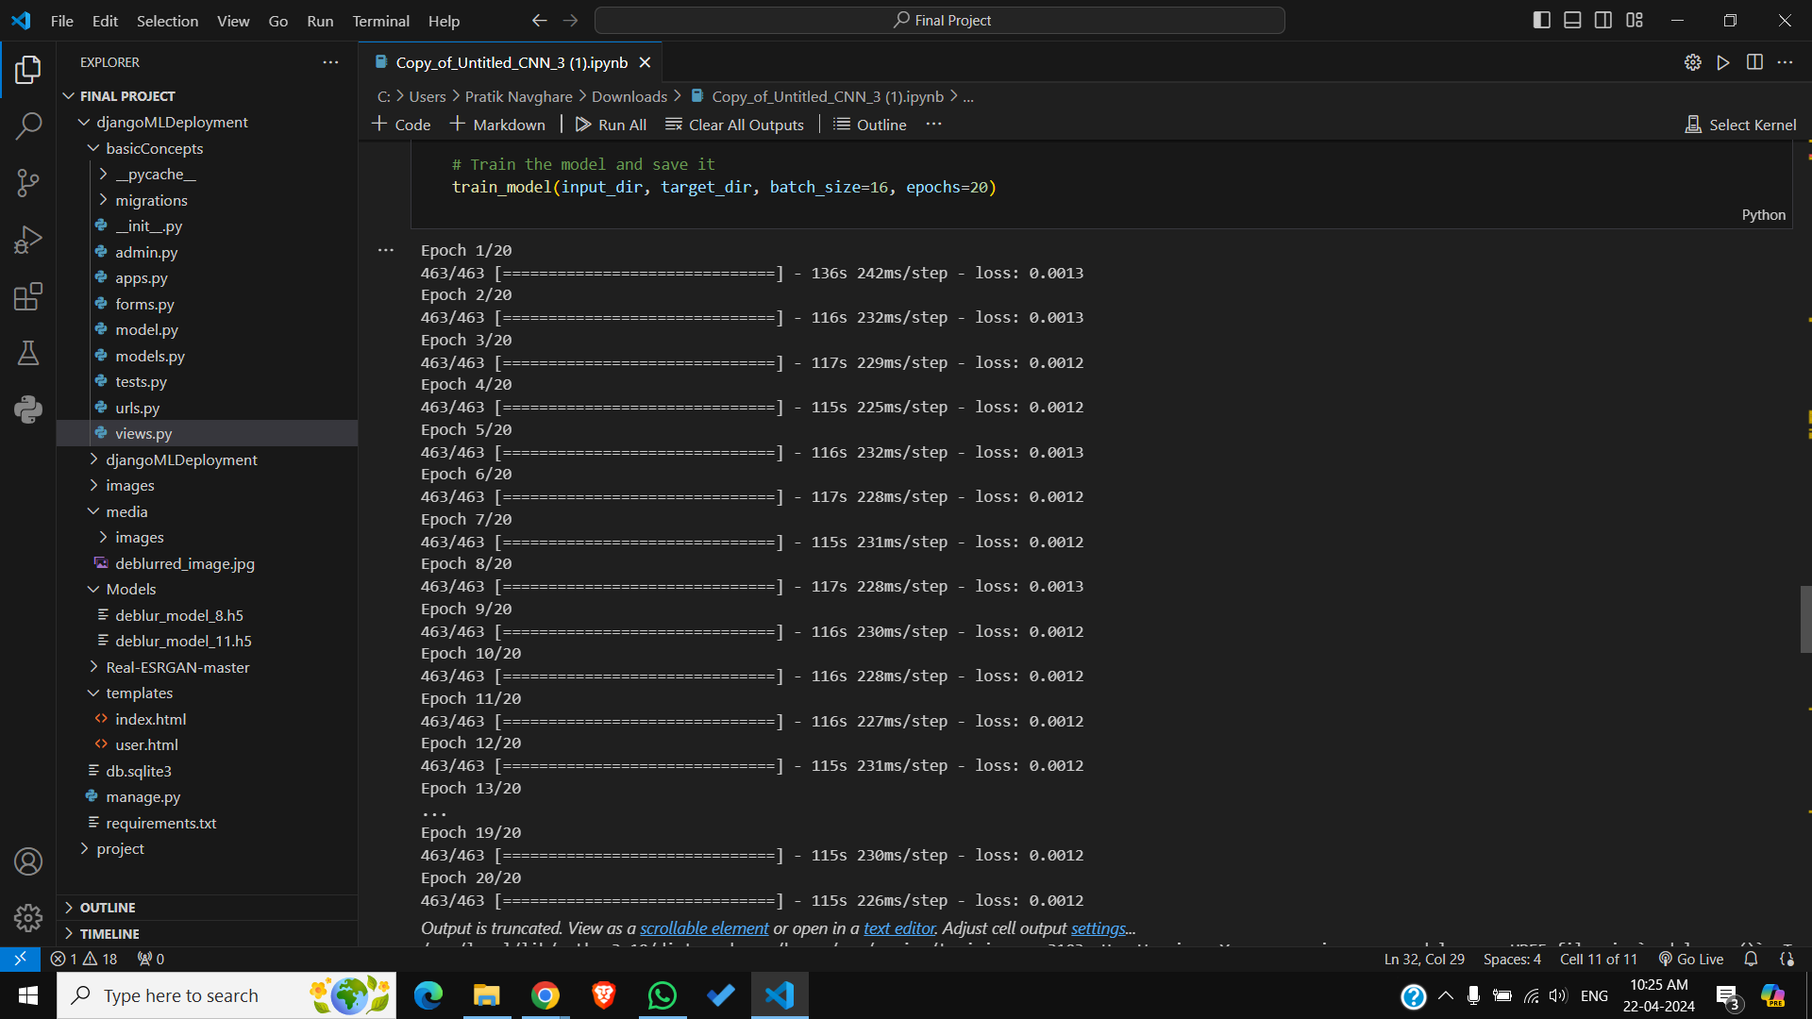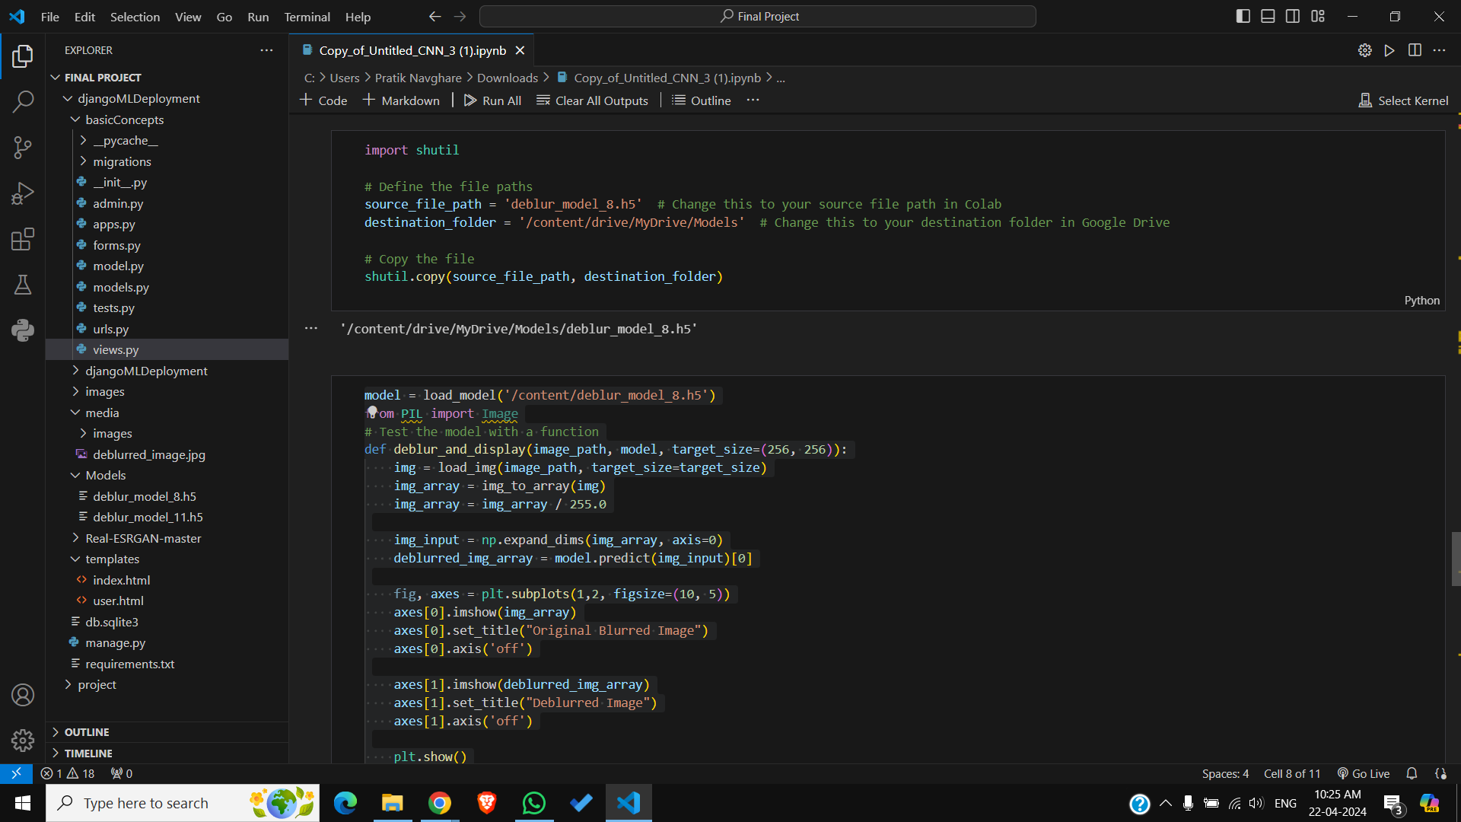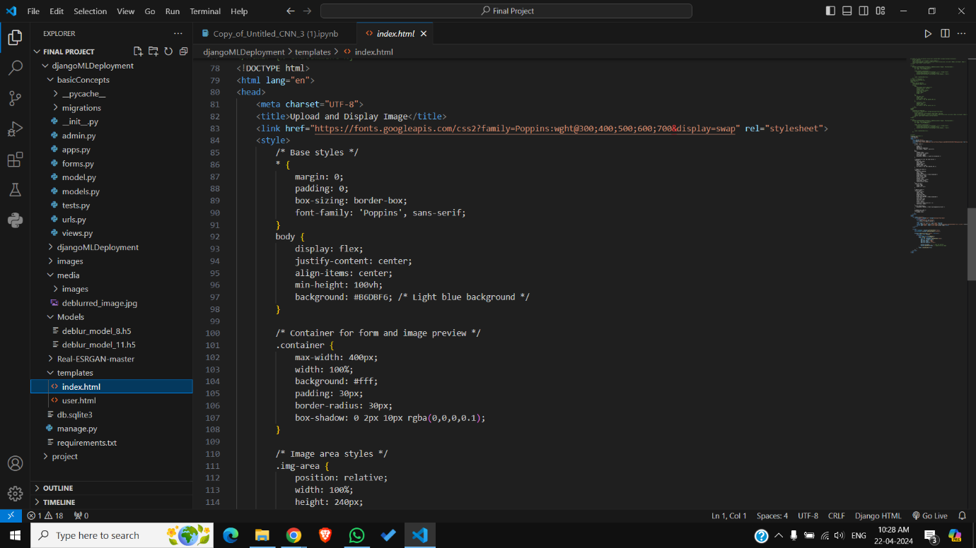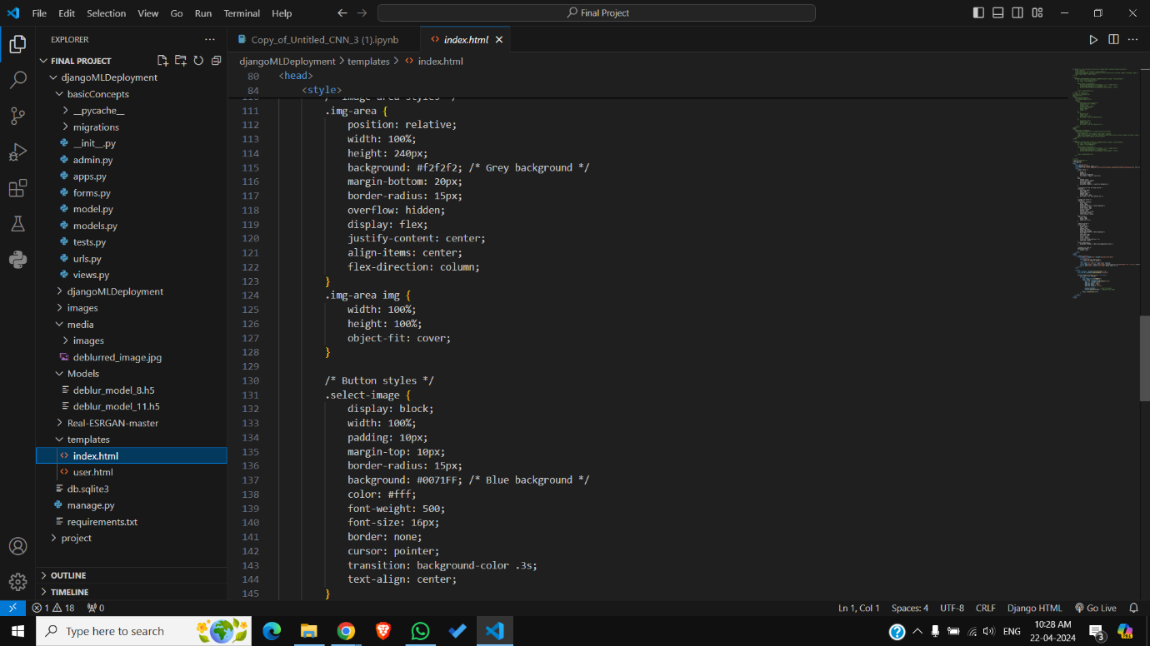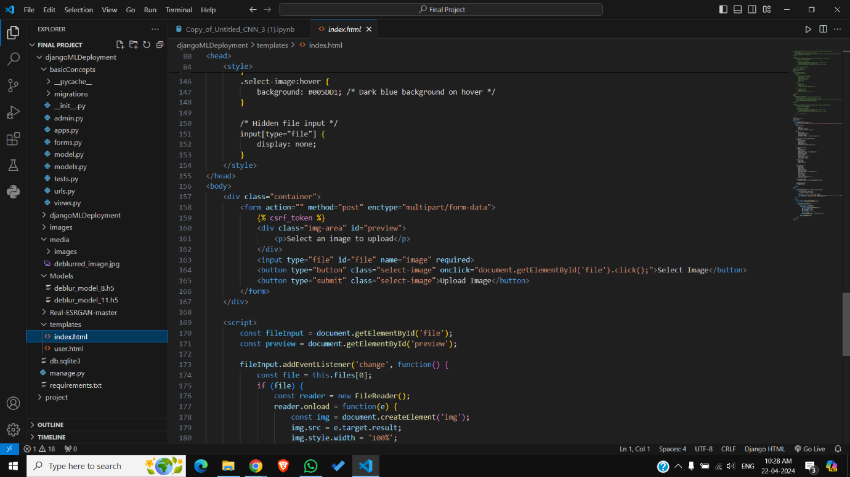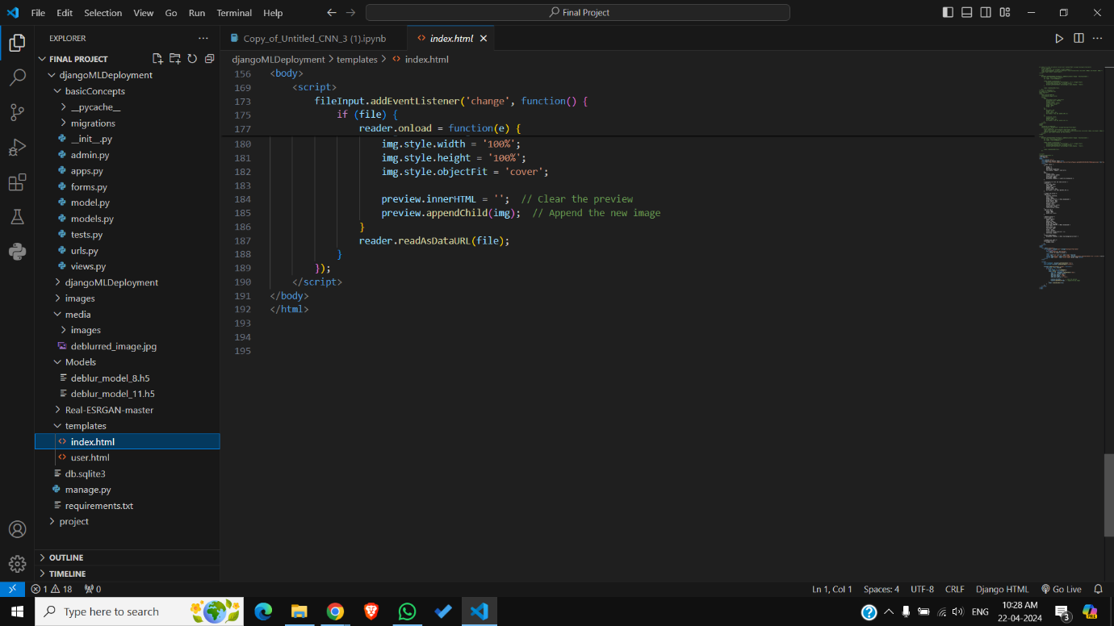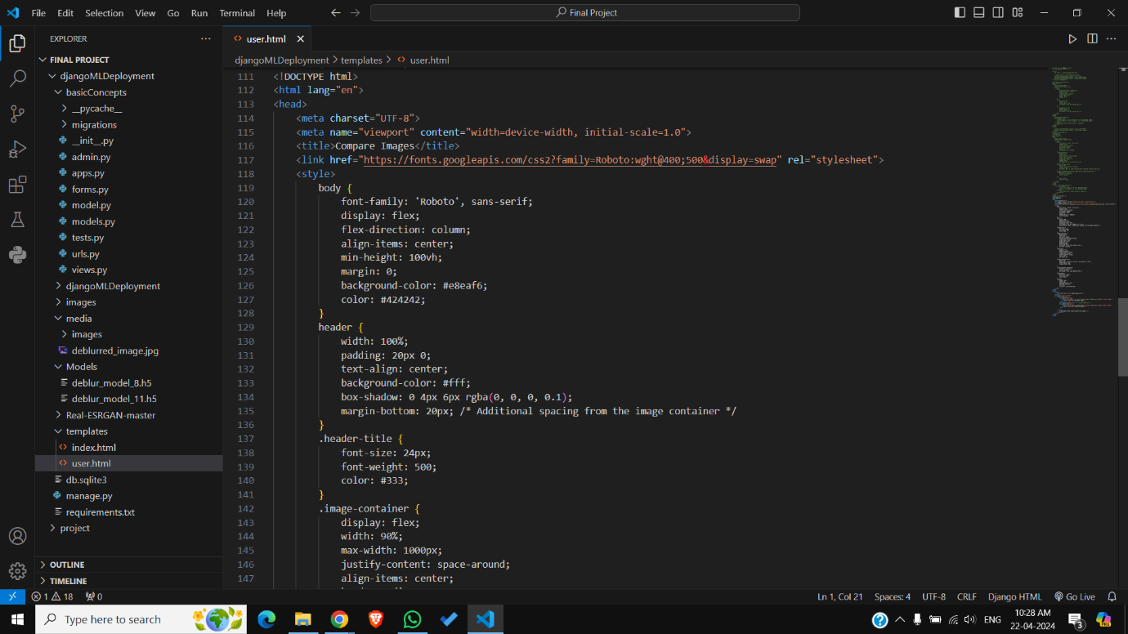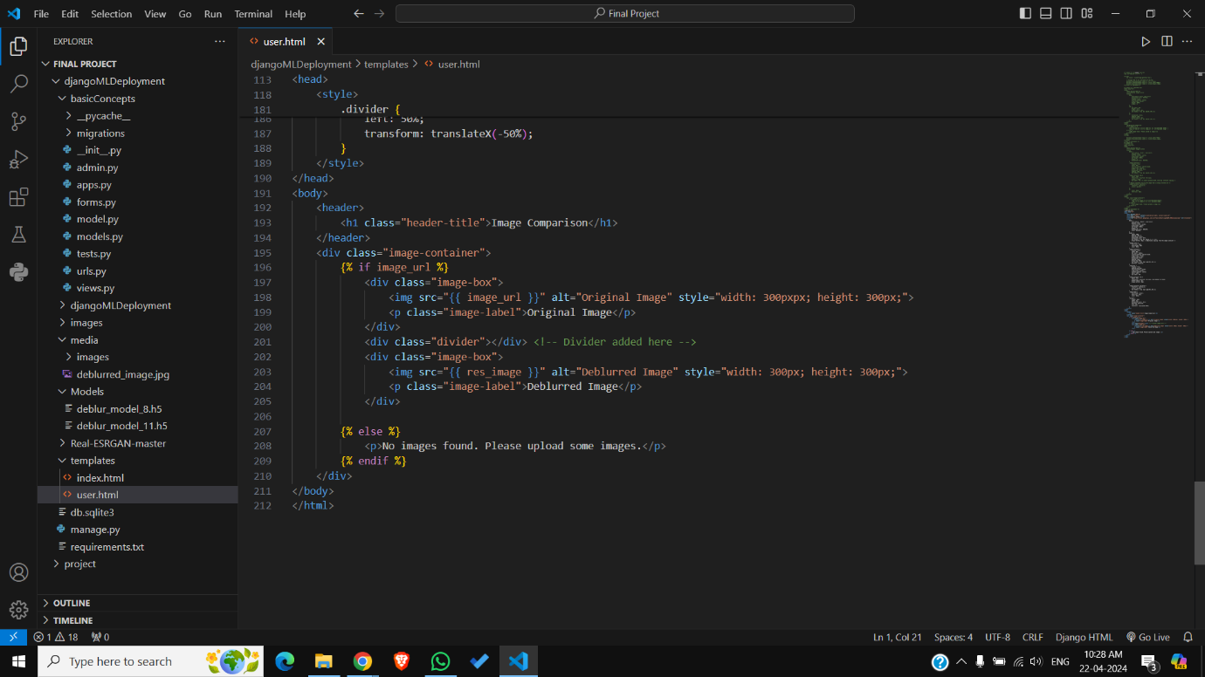

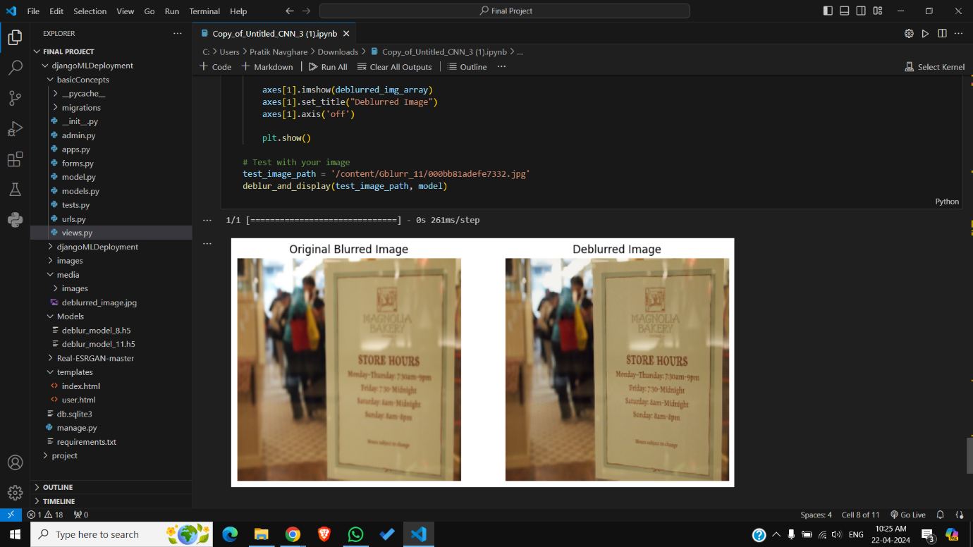 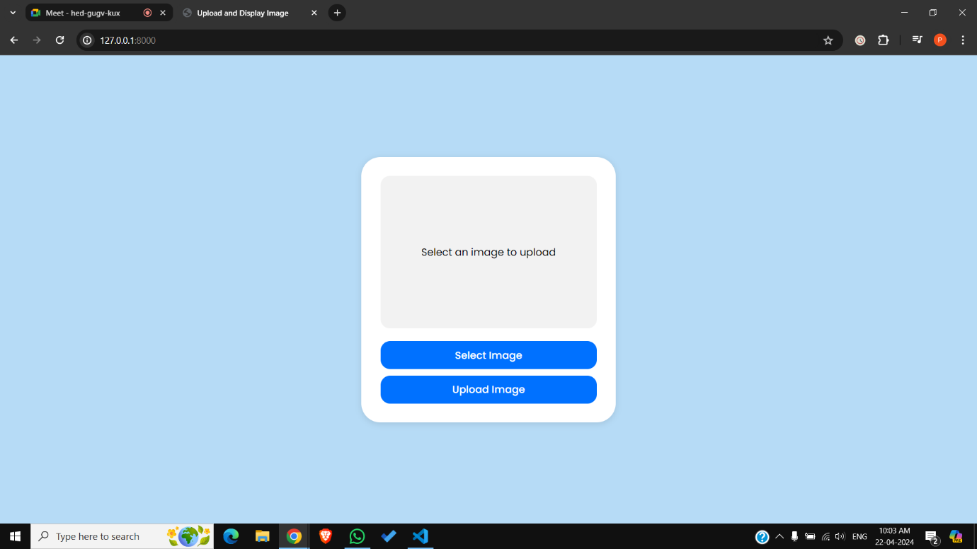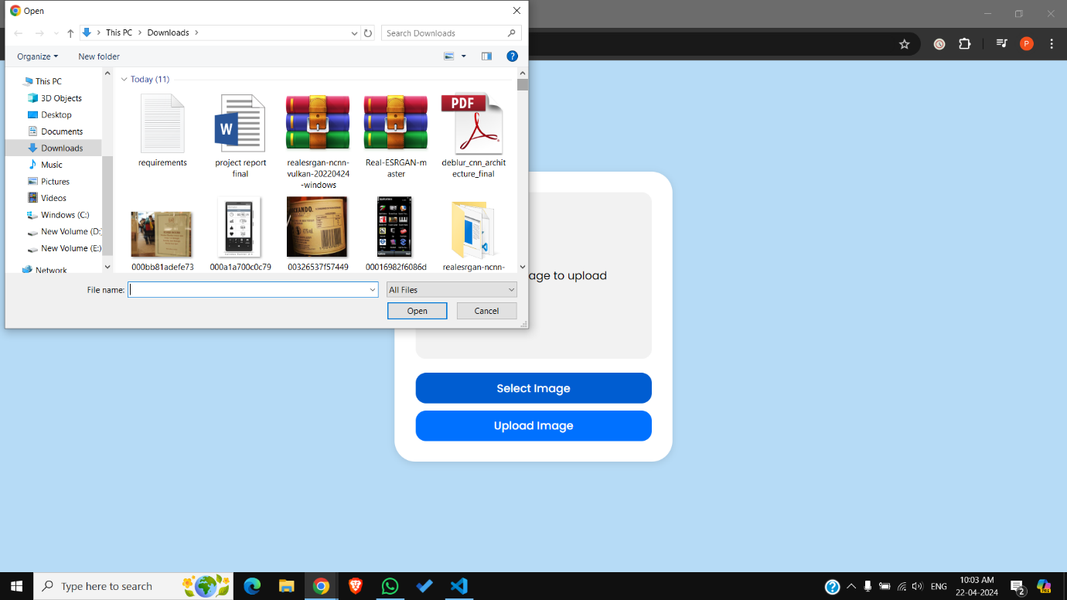

**REFERENCES**

[1] Towards Real-World Blind Face Restoration With Generative Facial Prior

Xintao Wang, Yu Li, Honglun Zhang, Ying Shan; Proceedings of the IEEE/CVF Conference on Computer Vision and Pattern Recognition (CVPR), 2021, pp. 9168-9178.

[2] Image Deblurring Based on an Improved CNN-Transformer Combination Network

by Xiaolin Chen ORCID, Yuanyuan Wan, Donghe Wang and Yuqing Wang

Changchun Institute of Optics, Fine Mechanics and Physics, Chinese Academy of Sciences, Changchun 130033, China.

[3]Recent Progress in Image Deblurring Ruxin Wang Dacheng Tao Centre for Quantum Computation & Intelligent Systems Faculty of Engineering & Information Technology University of Technology Sydney.